**CdTe/CdS Solar Cells and the**

**Growth of CdTe Nanowires**

*(1st year PhD transfer report)*

**Author:** Benjamin Luke Williams

**1st Supervisor**: Prof. Ken Durose

**2nd Supervisor**: Dr. Douglas Halliday





**Contents**

|  |  |
| --- | --- |
| **Section 1: Introduction** |  |
| 1.1.1: Energy climate and photovoltaics | *1* |
| 1.1.2: Project outline | *2* |
| 1.1.3: Nanostructures for photovoltaics | *2* |
|  |  |
| **Section 2: Literature Review** |  |
| ***2.1 – Photovoltaic basics*** |  |
| 2.1.1: Photovoltaic device operation | *4* |
| 2.1.2: Simple device design | *5* |
| 2.1.3: Electrical representation and J-V characteristics | *7* |
| 2.1.4: Types of solar cell and their processing | *9* |
| ***2.2 – Quantum structures*** |  |
| 2.2.1: Low dimensional solids and applications | *10* |
| 2.2.2: Mechanisms of fabricating nanowires | *15* |
| 2.2.3: Examples of nanowire growth | *20* |
| 2.2.4: Nanowires in photovoltaics | *21* |
| ***2.3 – Cadmium telluride photovoltaics*** |  |
| 2.3.1: Thin film CdTe PV and recent developments | *23* |
| 2.3.2: Sputtered CdTe PV | *24* |
| 2.3.3: CdTe nanowires | *24* |
|  |  |
| **Section 3: Experimental Techniques** |  |
| 3.1.1: Deposition methods | *26* |
| 3.1.2: Characterisation methods | *27* |
|  |  |
| **Section 4: CdTe/CdS Devices by Close-Space Sublimation** |  |
| 4.1.1: Experimental procedure | *29* |
| 4.1.2: Performance characterisation | *29* |
| 4.1.2: Discussion | *31* |
|  |  |
|  |  |
| **Section 5: CdTe/CdS Devices by Sputtering** |  |
| 5.1.1: Experimental procedure | *33* |
| 5.1.2: Performances of three distinct populations | *34* |
| 5.1.3: SEM and EDX | *37* |
| 5.1.4: Discussion | *37* |
|  |  |
| **Section 6: CdTe Nanowire Growth** |  |
| ***6.1 – Self assembly of Au nanodots by annealing*** |  |
| 6.1.1: Experimental procedure | *39* |
| 6.1.2: Results and discussion | *40* |
| ***6.2 – Nanowire growth by close space sublimation*** |  |
| 6.2.1: Experimental procedure for wire growth | *44* |
| 6.2.2: Preliminary results and discussion | *45* |
| 6.2.3: Secondary results following procedure changes | *47* |
|  |  |
| **Section 7: Conclusion and Future Work** | *52* |
|  |  |
|  |  |
|  |  |
|  |  |

**Section1: Introduction**

***1.1.1: Energy climate and photovoltaics***

Recent government proposals to dramatically increase the reliance on renewable energy sources reflect increasing public awareness of the environmental impacts associated with continued dominance of fossil fuels in the energy sector. The lofty targets set for 2020 and beyond have highlighted the requirement for a sustained progression of research in the field of renewable energy. The understanding of fundamental processes and the development of cost-effective manufacturing techniques are both aspects of this. Solar energy is just one of a number of sustainable technologies that must be optimised to enable it to be a part of the diversification of energy generation.

Currently, renewables are estimated to provide around 17% of global primary energy, with most of this supplied by hydroelectric, geothermal and biomass in developing countries1. Solar energy only provides a fraction of a percent of developed countries’ energy needs. In 2003, the approximate annual output of photovoltaics was estimated at 1 TWh/year, despite projections that there is potentially between 12,000 and 40,000 TWh/year of useful solar energy to be utilised. The most prevalent factor that causes this discrepancy is the elevated cost of solar energy, relative to standard fossil fuels. Electricity from photovoltaics is around 6 – 10 times the price of grid electricity. This is partly because the vast majority of photovoltaic modules sold are made from crystalline silicon. This is an indirect band-gap semiconductor, which has a relatively low absorption coefficient, and consequently thick wafers of silicon are required for effective light capture.

In contrast, direct semiconductors such as GaAs, CdTe and amorphous Si are able to sufficiently absorb light, using much thinner layers of material. First Solar Inc. boast that their thin-film CdTe modules use ‘*less than 2 % of the equivalent semiconductor material found in crystalline silicon PV modules’*.2 In parallel with the search for cheaper solar materials (which has contributed to the growth of organic photovoltaics) more novel methods of reducing costs have been posited. Textured absorber layers, or even ordered nano-structured absorber layers, could potentially perform just as well as their bulk counterparts, but whilst using a fraction of their volume. Such nanoparticles and nanowires exhibit attractive physical properties that could well be incorporated into a wide variety of optoelectronic devices – notably photovoltaic cells.

***1.1.2: Project outline***

At Durham, thin-film CdTe/CdS devices are fabricated using close space sublimation to deposit the active layers. To date, the best performing cell achieved an efficiency of 16.1%. The initial stage of this project will be to undertake each of the cell making steps and to assess the reproducibility of high performance devices, by electrical characterisation. It is also noted that little work has been reported of CdTe cells fabricated entirely by sputtering, a deposition technique used primarily for growing transparent conducting oxides. The second stage of the project was to process such devices, and establish a baseline for performance. Finally, research towards the design of a nanostructured CdTe/CdS device was begun. With the aim of fabricating a full device in mind, a feasibility study of the growth of CdTe nanowires was made. Details of the proposed structure of such a device is summarised below in section 1.1.3.

***1.1.3: Nanostructures for photovoltaics***

Due to the attractive optical and electric properties of one-dimensional structures (Section 2.2) the idea of integrating nanowires into photovoltaics is becoming increasingly popular. Simply by changing the physical dimensions of nanostructures, band-gap manipulation is also achievable. As a result, nanostructured, predominantly nano-crystalline solar cells can theoretically perform above the Shockley-Quiesser limit (*η* ~ 30%) by combining structures of different size to yield broad-band absorption3. Alongside organic photovoltaics, multi-junction cells and intermediate band-gap cells, nanowire solar cells are considered a ‘third-generation’ photovoltaic technology.

The growth of CdTe nanowires is relatively unreported compared to that of Si and a number of III-V semiconductors. It is felt that the advantages of the CdTe/CdS system, summarised in Section 2.3.1, can be utilised in a nanostructured device. A CdTe/CdS device, whereby CdS nanowires were used as the window layer, has been reported by Fan *et al.,* and it’s performance was promising (*η* = 6%).4 The author is unaware of any reports of a device as described below, in Figure 1.1, however. There are also no reports to the author’s knowledge of the successful growth of CdTe nanowires onto a Si substrate by the vapour-liquid-solid process (described in Section 2.2.2). Initial results of CdTe nanowire growth in this project is detailed in Section 6.

*A CdTe/CdS nanowire solar cell*

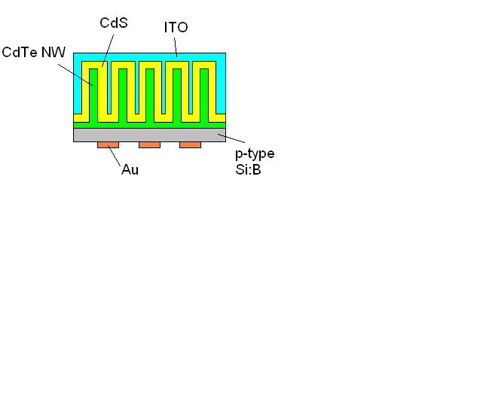

*Figure 1.1: Proposed device structure for a CdTe/CdS nanowire solar cell*

The proposed device design for a CdTe/CdS nanowire device is illustrated in Figure 1.1. Ideally there would be a base ‘protective’ layer of CdTe on the p-type Si substrate so to create a continuous junction. Without this, poor Si:B/CdS junctions would limit the open circuit voltage. Following array optimisation, an n-type CdS layer will be deposited via chemical bath deposition, upon which a transparent front contact (ITO) will be sputtered. Au contacts are to be thermally evaporated onto the back surface of the Si. There are obvious limitations, such as the resistivity of the Si substrate (1 – 30 Ω.cm), but the motivation of these preliminary investigations is to establish whether the fabrication of such a device is feasible, and to demonstrate whether it exhibits characteristic photovoltaic behaviour.

**Section 2: Literature Review**

This section describes the fundamental physics of photovoltaic devices, and of low dimensional structures, with added emphasis on nanowires. It also goes on to summarise recent work in both fields. The final sub-section details recent developments in CdTe photovoltaics.

**2.1 - Photovoltaic basics**

***2.1.1: Photovoltaic device operation***

*The p-n junction*

The simplest model of a solar cell consists of a p-n junction, connected in a circuit. Figure 2.1illustrates a p-type semiconductor being brought into contact with an n-type semiconductor and the resulting band profile of the p-n junction5. *EC*, *EV*, *Evac* and *EF* are the conduction and valence band edges, the vacuum energy level and the Fermi energy level respectively. *Φp* and *Фn* are work functions and *Vbi* is the built in voltage of the junction.

*Figure 2.1: Electric band diagram of a) a p-type semiconductor being brought into contact with an n-type semiconductor and b) the resultant band-bending associated with the formation of a p-n junction.*

Physically, there is a concentration gradient of charge carriers when the materials are brought together. Excess electrons diffuse from the n-type semiconductor to the p-type semiconductor and vice versa for the excess holes from the p-type, until equilibrium is reached. The majority carriers leave fixed ions at the interface of the junction, and an electric field is established which presents a barrier to further majority diffusion but creates a low resistance path to minority carriers. This region at the interface is almost completely depleted of mobile carriers and is therefore called the ‘depletion region’6. The built in voltage is shown in Figure 2.1b, resulting from the band bending that occurs as the Fermi energy level reaches equilibrium. Semiconductors can be made p or n-type by impurity doping; for example doping Si with B makes it p-type. More complicated hetero-junctions, in which the p and n-type semiconductors are made from different materials exhibit discontinuities at the junction as their energy gaps (*Eg* = *EC* – *EV*) are not equal.

*The photovoltaic effect*

An electron can be excited from the valence band, across the energy gap into the conduction band by a photon of energy, *hv* > *Eg*. If this excitation occurs in a p-type material, which is connected in a p-n junction, then the electron will ‘drift’ to the n-type material, swept across by the built in electric field. Similarly, an excitation within the n-type material will result in a hole being swept to the p-type. By connecting the junction into a circuit, these charge carriers can be collected, contributing to an electric current. Photons with an energy, *hv* < *Eg*, will pass through without being absorbed whilst photons of energy *hv* > 2*Eg*, may excite an electron with sufficient energy to create further electron hole pairs7.

***2.1.2: Simple device design***

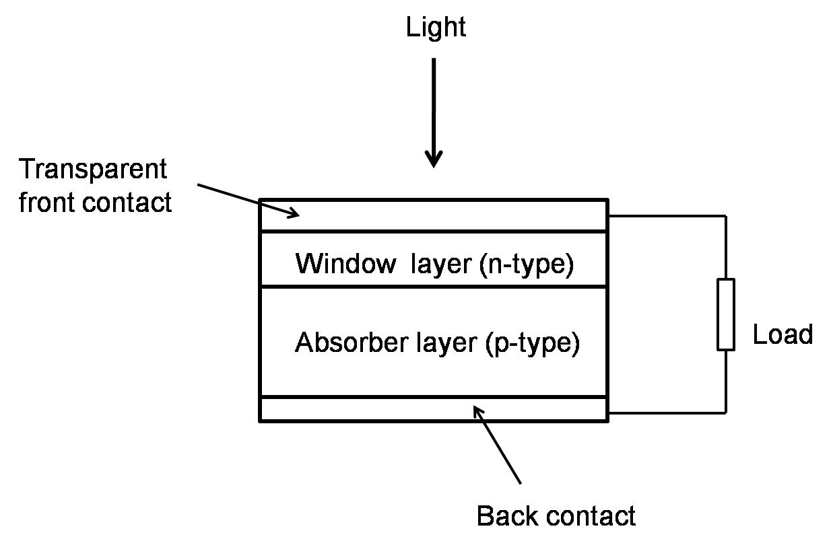

*Figure 2.2: The basic layer structure of a solar cell; a p-n junction, contacted and connected in a circuit.*

*The absorber layer*

The absorber layer is the thickest layer in a device, to limit the transmittance of longer wavelengths and optimise absorption. Typically for a crystalline silicon wafer cell, the absorber layer is a few hundred microns thick5. This is greatly reduced in thin-film cells, in which materials with a higher optical absorption coefficient, *μA*, are used, such as cadmium telluride (*μA* > 5 x 105 cm­-2). Minority carrier mobility tends to be higher in a p-type layer, therefore it is typical to design the cell so that the thicker absorber layer is p-type. This layer is lightly doped (~ 1016 cm-3) to improve diffusion lengths.

The band-gap of the absorber layer dictates the maximum wavelength of light that can be absorbed. Figure 2.3 shows the AM1.5 solar spectrum, marked with the Si band-gap; photons with wavelength greater than 1100 nm do not have sufficient energy to promote an electron into the conduction band. However, electrons excited by photons of energy, *hv* > *Eg*, lose their excess energy via heat transfer during charge transport. Furthermore, if the band gap is too small, then the associated low voltage will result in low efficiency. For the AM1.5 spectrum, the optimal band-gap is approximated to be 1.4 eV.8

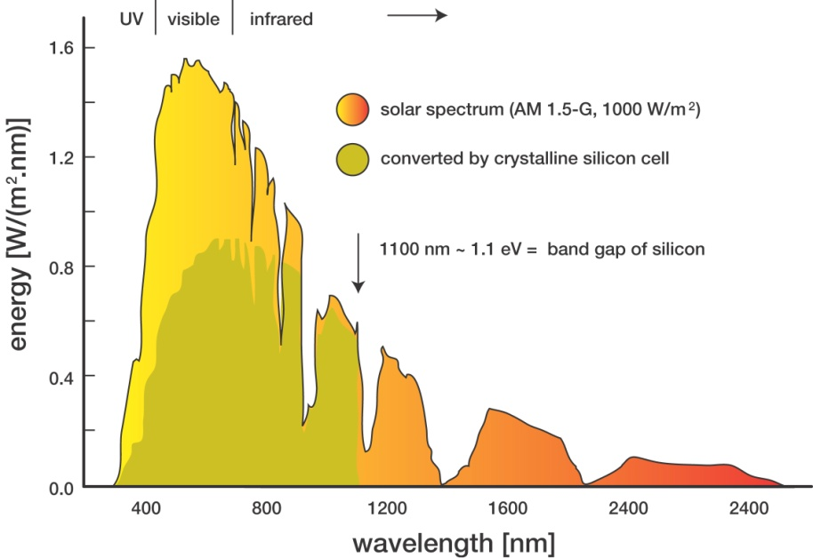

*Figure 2.3: Air Mass 1.5 solar spectrum, noting the band gap of silicon*

*The window layer*

This is heavily n-type doped (~ 1019 cm-3) to reduce sheet series resistance. It should be thin enough to allow light to transmit through to the absorber layer, but thick enough to minimise series resistance (typically a few hundred nanometres). In hetero-structured cells, the window layer has a wider band gap than the absorber, to optimise transmission. Window/absorber layer combinations should also be chosen with a consideration of their lattice mismatch. Largely mismatched systems will be highly strained, causing dislocations to form, in which charge can be trapped and recombination events occur to greatly reduce diffusion lengths6.

*The transparent front contact*

A number of photonic devices require some form of transparent contact. These doped metal oxides (transparent conducting oxide) are designed to compromise between sufficiently high transmittance (> 80%) and sufficiently low sheet resistance (< 10Ω/). A typical example is indium tin oxide (ITO), which has a very wide band gap (Wang *et al.* report *Eg* = 3.28 – 3.77 eV), which is required for optimising transmission9. However, indium is known to diffuse from the ITO layer, forcing the requirement of a protective ‘buffer’ layer, often in the form of ZnO.10

*The back contact*

Back contacts must be highly conductive, stable and will ideally form an ohmic contact. To certain semiconductors however, this can prove difficult. For a metal/p-type contact, the metal must have a sufficiently large work function, or a Schottky barrier will form7. This has the effect of introducing a diode opposing that of the p-n junction; contribution to series resistance.

***2.1.3: Electrical representation and J-V characteristics***

As stated in Section 1.1.3, the peak theoretical efficiency obtainable in a solar cell from the AM1.5 spectrum is ~ 30%. Shockley and Queisser arrived at this value by considering the balance between using a wide band-gap absorber, in which high wavelengths are lost and low photocurrent is observed, and using a narrow band-gap absorber, which yields a low voltage (*V* at maximum power is always less than *Eg*). Incident light is also lost via reflection from the top surface, absorption in the front contact and window layer, and transmission through the absorber layer. Energy harvested through absorption can then be lost internally through series resistance and shunting. Electrons diffusing through the device may recombine with holes that have been created by other excitations; this is a cause of series resistance, along with phonon and impurity scattering, and contact resistances. Shunting pathways allow current to leak through the cell, or around the edges of the device. A high shunt resistance is beneficial to cell operation. These resistances are incorporated into the equivalent electrical circuit of a photovoltaic device, as shown in Figure 2.4. The shunt resistance is in parallel with the diode that is effectively formed at the p-n junction5.

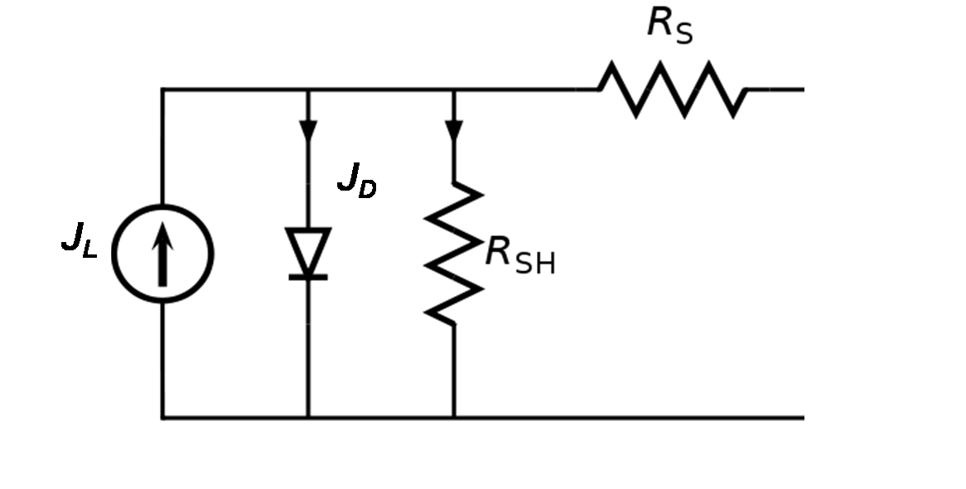

*Figure 2.4: Equivalent circuit for a photovoltaic device, including shunt, RSH, and series, RS, resistances. JL and JD are the photo-generated and dark current densities respectively.*

To measure the electrical characteristics of a solar cell, a bias is applied and the current is measured, both in dark and light conditions. The dark current acts in the opposite direction to the photocurrent, and is generated by the potential difference, developed when a load is present. Majority carriers are thermally generated and the dark current, *JD*, is calculated using the Shockley-Diode equation (Equation 2.1), where *J0* is the reverse saturation current density, *kB* is Boltzmann’s constant, *A* is the diode ideality factor and *q* is the charge of an electron7.

|  |  |  |
| --- | --- | --- |
|  |  | (2.1) |
|  |  |  |

This equation is modified when a light source is applied, simply by subtracting a photo-generated current density term, *JL*.

|  |  |  |
| --- | --- | --- |
|  |  | (2.2) |

The efficiency of a photovoltaic device is given in Equation 2.3, where *Pmp* is the maximum power and *PS* is the power of the incident radiation.

|  |  |  |
| --- | --- | --- |
|  | $$η=\frac{P_{mp}}{P_{S}}$$ | (2.3) |

The generated J-V curve enables extraction of values for the open circuit voltage, *VOC*, which is the applied bias at which the net current through the device is zero, the short circuit current, *JSC*, which is the current flowing at zero bias, and the fill factor, *FF*, which measures how square the curve is. As the maximum power is given by the product of these three terms, the efficiency can now be expressed by Equation 2.4.

|  |  |  |
| --- | --- | --- |
|  | $$η=\frac{V_{oc}J_{sc}FF}{P_{S}}$$ | (2.4) |

Approximate expressions for the shunt and series resistances can be obtained from Equation 2.2. Under high *RS*, *RSH* conditions, the series resistance is given by Equation 2.5 at the open circuit voltage point of the J-V curve. Under low resistance conditions, the shunt resistance can be approximated by Equation 2.6 at the short-circuit current point5.

|  |  |  |
| --- | --- | --- |
|  |  | (2.5) |

|  |  |  |
| --- | --- | --- |
|  |  | (2.6) |

For alternative, more comprehensive techniques to determine sheet and series resistances in solar cells, see work by Zoppi or Al-Turkestani.11, 12

***2.1.4: Types of solar cell and their processing***

Due to its abundance, its presence in the semiconductor industry and its suitable band-gap, Si has been the dominant photovoltaic material for over 50 years13. Crystalline Si is split into four categories; single-crystal (grain > 10 cm), multicrystalline (1 mm – 10 cm grains), polycrystalline (1 μm – 1 mm) and microcrystalline (< 1 μm). Single crystal cells are the most expensive to manufacture but with the benefit of having much improved efficiency, as a result of reduced recombination rates. The University of New South Wales has achieved 25% efficiency for a single crystal Si cell14. Typically p-type single crystal Si is grown by the Czochralski method15, and a slice of a few hundred microns is used. About 0.1 – 0.5 μm of this wafer is n-type doped with phosphorous. Single crystal GaAs and InP devices have also demonstrated efficiencies greater than 10%.

Although the reduction of material usage in thin-film cells potentially reduces cost, attention must be paid to the processing costs of large area production. Thin films can be deposited via a number of processes; chemical vapour deposition, thermal evaporation, electro-deposition, molecular beam epitaxy, close space sublimation or sputtering. First-Solar, Inc. currently leads the thin film market, concentrating on CdTe modules. In 2009, they produced 1.1GW, achieving an average efficiency of 11%. The current world record for a laboratory made CdTe thin film device was achieved by Wu *et al.*, and stands at 16.5%.16 This is eclipsed by GaAs thin film devices, which have a peak efficiency of 26.1%, approaching the theoretical limit17. Research into a number of different materials (e.g. CuInGaSe, amorphous Si) for thin film photovoltaics is being undertaken, in search of cheaper alternatives.

The idea behind multi-junction cells is that a broad range of the solar spectrum can be captured by using two or more absorber layers, of different band-gaps, and so they can theoretically exceed the single-junction limit. This has been achieved by King *et al.*, who processed a triple-junction GaInP/GaAs/Ge cell, achieving an efficiency of 32.3%. The device structure is complex, with a number of thin film active layers, buffer layers and tunnelling junctions incorporated18. Dye-sensitised cells have reached a peak efficiency of 10.4%, and organic polymer cells, which are possibly the cheapest to manufacture, have achieved 5.2%, although their stability is commonly poor14.

**2.2 – Quantum structures**

***2.2.1: Low Dimensional Solids and Applications***

When a solid’s dimension is reduced sufficiently so to become comparable to the Fermi wavelength, *λF* (Equation 2.7), its charge carriers are ‘confined’ in that dimension and the sample becomes known as a low dimensional solid19. *kF* is the Fermi wavevector.

|  |  |  |
| --- | --- | --- |
|  | $$λ_{F}= \frac{2π}{k_{F}}$$ | (2.7) |

A 2D structure for example, confined in one dimension, is called a quantum well and a 1D structure, confined in two dimensions is known as a quantum wire. Over recent decades, technological advancements have yielded the opportunity to fabricate such structures. A quantum well can be constructed by depositing a thin film A-B-A stack whereby semiconductor B (of thickness 5 – 100 Å) has a conduction band edge lying lower than that of semiconductor A. Quantum wire fabrication methods are detailed in Section 2.2.2. Changes to the electrical and optical properties of systems brought about by quantum confinement have generated much interest in the field. The efficient charge carrying capabilities and optical enhancements of quantum/nanowires have prompted a number of possible applications for 1D systems, such as quantum wire lasers20, quantum computing21, superconductivity22, light emitting diodes23 and photovoltaics4.

*Electronic states*

Altering the dimensionality of a solid has significant effects on its electronic states. The energy levels in the direction of confinement become quantised, forming ‘sub-bands’ with energies as described by Equation 2.8.

|  |  |  |
| --- | --- | --- |
|  | $$E= \frac{ℏ^{2}π^{2}}{2m^{*}}\left[\frac{l^{2}}{a^{2}}+\frac{m^{2}}{b^{2}}+\frac{n^{2}}{c^{2}}\right]$$ | (2.8) |

Here, *l*, *m* and *n* are quantum numbers, *a*, *b* and *c* are the solid’s dimensions and *m\** is the effective mass. For a quantum wire, *c* (length) is large and so the sub-band separation is small, giving a quasi-continuum of states, whereas *a* and *b* are small, resulting in very large sub-band separations, i.e. they are quantised.

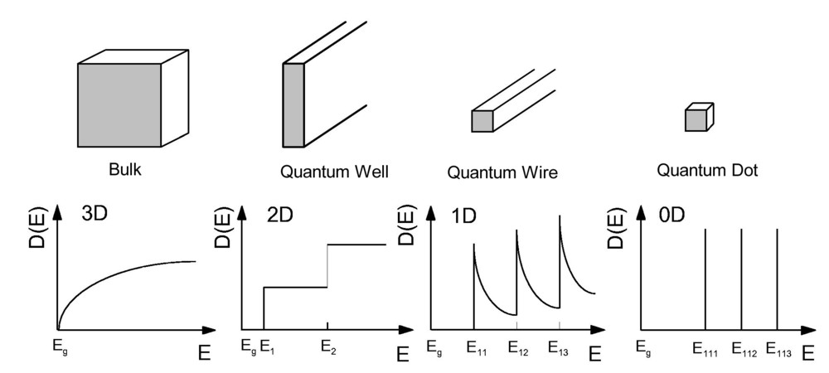

*Figure 2.1: Density of states for solids of varying dimensions.*

The effect of confinement on the density of states (DOS) is illustrated in Figure 2.1, with the extreme case for a 0D system (a quantum dot) in which the DOS is reduced to a series of delta functions corresponding to the energies of the sub-bands. For a bulk 3D solid, the DOS is given in Equation2.9 and equates to a continuous distribution.

|  |  |  |
| --- | --- | --- |
|  | $$N_{3D}(E)= \frac{\sqrt{2}m^{3/2}E^{1/2}}{π^{2}ℏ^{3}}$$ | (2.9) |

*ħ* is the reduced Planck constant. Equation 2.10 shows that the density of states for a 1D system has discontinuous steps relating to the sub-band energies, and an *E*-1/2 dependence in between.

|  |  |  |
| --- | --- | --- |
|  | $$N_{1D}= \sum_{i}{\frac{1}{π}{\left[\frac{2m}{ℏ^{2}}\right]}^{\frac{1}{2}}{\left[E-E_{i}\right]}^{-\frac{1}{2}}H(E-E_{i})}$$ | (2.10) |

*Ei* is the energy of sub-band *i* and H is the Heaviside function, H(*x*), where H(x) = 1 when x ≥ 0 and H(*x*) = 0 when *x* < 0.

*Transport properties*

As mentioned, one of the most attractive properties of quantum wires is their potentially high levels of mobility. For samples with dimensions smaller than the mean free path (the average distance between collisions), conduction is said to be via ballistic transport. For a quantum wire, this would of course apply to radial conduction, which is an important mechanism in the context of nanowire photovoltaics. With further reduction of the wire width to Fermi wavevector scale, the conductance, *G*, is quantised into steps of *2e2/h*. This is derived from Landauer’s formula (Equation 2.11), in which *Tj* is the transmission probability through channel *j* (equal to 1 within the ballistic regime) and *N* is the number of conduction channels24.

|  |  |  |
| --- | --- | --- |
|  |  | (2.11) |

Quantum corrections to transport along the length of the wire are highlighted at low temperatures (< 10K), but even at room temperature it is predicted that the suppression of scattering rates can lead to increased mobility. At room temperature, more Boltzmann-like treatments are used, taking into account Coulomb scattering, interface roughness scattering and phonon scattering19. Clearly scattering within one dimension can only be forward or backward and so the only relevant wave vector transfer is 2*kF*, as opposed to a continuous range in the case of a 3D system. Since the scattering cross section decreases rapidly with increasing momentum transfer, you would expect a significant reduction in scattering. Theoretical results have shown that the emission rate of longitudinal-acoustic phonons decreases as you confine a solid in more dimensions. The difference between 2D, 1D and 0D systems was reduced as the sample dimensions were increased above confinement scales25. Also, by engineering the sub-bands of a wire array correctly, the longitudinal-optical phonon transitions can be made to be forbidden26.

Inevitably there is an optimum diameter range for quantum wires (nanowires) to benefit from improved transport properties. Reducing the diameter of GaAs wires from 320nm to 300nm resulted in a three-fold mobility increase whilst Fonoberov *et al.* posits that Si nanowires exhibit mobility levels greater than their bulk counterpart for diameters within the range of 8-20nm27, 28. Experimentally, the theoretical mobility improvements are commonly quenched by process-induced defects. Reports of defect free nanowire growth are detailed in Section 2.2.3, however. Additionally, coating wires in a hard material such as diamond has been shown to enhance mobility28, as has encapsulating the wires in metal, so to reduce the scattering potential associated with interface optical phonons29.

*Optical properties*

The act of confinement also has profound effects on the optical properties of a material. Within a quantum well, only optical transitions between conduction and valence band sub-bands of the same parity are allowed. A staircase like variation is seen for the absorption spectrum, as observed for the 2D system’s density of states30. Absorption peaks become narrower as dimensionality is further reduced, as a result of the continued sharpening of the density of states. Another characteristic of quantum structures is the dimension dependence of their band-gap. The energy gap between discrete sub-bands within a quantum well is widened as you reduce the width of the well. Multiple quantum well solar cells are designed to utilise this property by incorporating wells of varying width, in an attempt to target a broader region of the solar spectrum31, 32. This ability to manipulate the band gap through controlling the size of a structure also applies to quantum wires. Nolan *et al.* demonstrated an increase in the band gap from 1.7 to 3.8eV following reduction of the diameter of silicon nanowires from 26 to 7 Å using density functional theory calculations33. Band-gap engineering is likewise achievable through compositional variation34.

The binding energy of an exciton is enhanced in low dimensional structures as confinement increases the overlap of the electron and hole wavefunction. This, in turn, enhances the Coulomb attraction and the exciton consequently exhibits a greater lifetime35. Recombination rates in inorganic solar cells are quenched as a result. There inevitably are non-linearity’s in the optics of 2D and 1D structures, which could be advantageous for optical switching and signal processing36.

One of the reasons that quantum wires, or at slightly larger scales, nanowires, are being incorporated into photovoltaic devices is their light harvesting capability, attributable to optical scattering. Much recent work is focussed on optimising nanowire dimensions and the structure of arrays. Tena Zaera *et al.* demonstrated that the reflectance intensity increased with wire length for randomly oriented ZnO arrays, whilst the reflectance peak experienced a red-shift when the wire diameter was increased37. Kelzenberg *et al.* used both photon absorption and carrier collection as measures for optimising wire diameter for photovoltaic application38. It was predicted that optimal efficiency is obtained if the wires had a diameter of the order of the minority-carrier diffusion length (2 – 10 μm for their Si nanowires). The results also suggest that absorption by vertically aligned nanowires is highly angular dependent, as a significant drop was recorded when light was incident perpendicular to the substrate. To reduce the angular dependence, either the nanowires could be randomly oriented, or light scattering nanoparticles could be embedded.

Optical path lengths are greatly reduced for nanostructures. Arrays must therefore be constructed with a particular geometry that yields excellent light trapping. Garnett et al. conclude that their periodic arrays of Si wires increase the path length by up to 73 times39.

*Plasmonics*

Plasmons, the quanta of oscillating charges, play an important role in the optical properties of metals. For example, only light of frequency greater than the plasmon frequency, *ωP* (Equation2.12)**,** can be successfully transmitted, because at lower frequencies the plasmon oscillations act to screen the light’s electric field. For Equation 2.12, *n* is the [electron](http://en.wikipedia.org/wiki/Conduction_electron) density, *e* is the [elementary charge](http://en.wikipedia.org/wiki/Elementary_charge), *m* is the [electron mass](http://en.wikipedia.org/wiki/Electron_mass) and *ε0* the [permittivity of free space](http://en.wikipedia.org/wiki/Permittivity_of_free_space).

|  |  |  |
| --- | --- | --- |
|  | $$ω_{P}= \frac{ne^{2}}{mε_{0}}$$ | (2.12) |

Surface plasmons occur at the interface of a dielectric and a conducting medium – ie. a vacuum and a metal40. They can either be propagating, on a grating surface, or localised, on the surface of a spherical particle. The excitation of [surface plasmons](http://en.wikipedia.org/wiki/Surface_plasmon) by light is known as surface plasmon resonance, and leads to electric field and absorption enhancement. Nanoparticles or nanowires of some noble metals exhibit very strong absorption bands in the ultra violet and visible wavelengths.

In surface-enhanced Raman scattering the field enhancement magnifies the intensity of the incident light, which excites the Raman modes and consequently increases the Raman scattering signal. This is in turn magnified in the same way as the incident light was, resulting in a total of an *E4* enhancement.

The plasmon resonant wavelength is dependent on the environment around the particles and the size and shape of the particles themselves. A red-shift of the peak wavelength of the extinction spectra has been observed when the size of gold nano-particles was increased from 20 – 100nm.41

The localisation of surface plasmons can be controlled by tailoring the quantum structures on a surface. In this way, they can essentially be used as waveguides to concentrate and channel light into structures. There are already a number of reports whereby quantum dots are deposited onto the surfaces of photovoltaic devices to enhance light absorption42, 43 or dispersed into the device itself to be used as a tuneable absorber44.

Surface plasmons in nanowires have been proven to have relatively long propagation lengths (10μm in silver nanowires at a light wavelength of 785nm)45 and it has been shown that the multi-polar plasmon resonances of metal nanowires can be described in terms of standing plasmon waves46. From the literature it is evident that applications for plasmons in nanowires are more likely to be in optical lithography and microscopy than in photovoltaics.

***2.2.2: Mechanisms of fabricating nanowires***

Nanowire synthesis mechanisms can be divided into two main categories. Firstly, direct patterning of materials enables a high level of accuracy and reproducibility, but it requires expensive, highly specialised equipment and is often a slow process. Commonly, electron beam lithography is used to pattern a polymer resist, through which material is deposited – usually by electro-deposition or chemical vapour deposition. Upon removal of the resist, perfectly periodic, uniform wire arrays remain47. Anodic alumina membranes can also be used as the template48. Secondly, bottom-up methods of fabricating nanowires rely on the natural self assembly of particles and avoid the requirement for expensive equipment. The materials that can be assembled into nanowires in this way are limited by the properties of the materials themselves. By definition, self assembly processes only occur if they are energetically favourable, and will be disrupted if inherent strains between certain elements are large enough. Nanowires have been grown by the solution-liquid-solid process49, the vapour-solid-solid mechanism50 and by oxide assisted growth51. The most popular mechanism however, the vapour-liquid-solid (VLS) process is described in more detail below.

*The Vapour-Liquid-Solid (VLS) mechanism*

The majority of work on nanowires utilises the process first described by Wagner and Ellis52 in 1964. Wagner proposed the concept to explain the vertical growth of silicon micro-whiskers, apparently nucleating from small gold particles on a Si <111> substrate. Figure 2.2 illustrates the key stages of the VLS mechanism. In reality the Au particle will wet the substrate more than is apparent in the figure, much like in the spherical drop model.

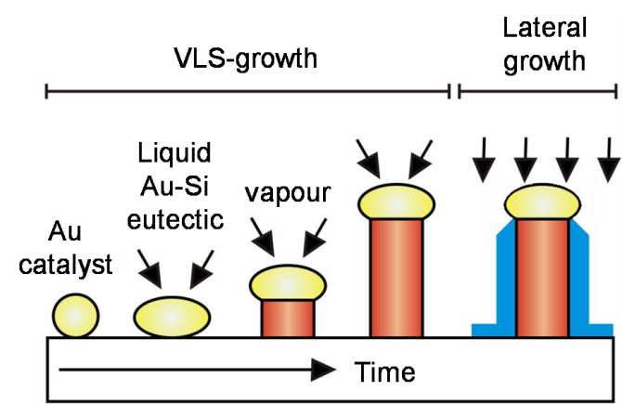

*Figure 2.2: Illustration of the key stages of the VLS mechanism. A nucleating particle, in this case Au, is deposited onto a substrate. Initial exposure to the source material leads to the formation of a liquid alloy of source material and catalyst material. When the gold saturates, the source material precipitates at the liquid-solid interface, thus lifting the initial gold particle. Further deposition causes a continuation of the vertical columnar growth.*

Wagner explains that an Au particle is placed on the Si substrate and heated to 950°C to form a Si/Au liquid alloy. Incidentally, the eutectic point of the Si-Au binary phase diagram is actually as low as 363°C53. A mixture of hydrogen and SiC4­ vapour is introduced by chemical vapour deposition (CVD) and the liquid alloy acts to lower the activation energy of normal vapor-solid growth. The Si vapour enters the alloy and once saturation is reached, Si precipitates at the liquid-solid interface, as this is energetically favourable, consequently lifting the Au particle up. This process repeats to form the micro-whisker. The catalyst diameter defines the liquid-solid interface and thus defines the diameter of the structure. In this case, the direction of growth is in the <111> direction, following the orientation of the substrate. There are countless reports of nanowires being fabricated using the VLS process, simply by using nanoscale particles as the catalyst. The mechanism of the self assembly of Au nanodots is detailed at the end of this section, and examples of VLS induced nanowire growth are detailed in Section 2.2.3.

*Growth properties of the VLS process*

As mentioned, the successful growth of nanowires using a bottom-up approach is restricted to certain material combinations. Nanowire growth is dependent on the ability of the catalyst and source material to form an alloy at the temperature used, and also on the thermodynamic properties of the phases present. For example, growth will become unstable if a perturbation causes the catalyst droplet to wet part of the sidewall of the nanowire during growth. An upward vertical force, arising from the surface tension, $σ_{L}$, of the droplet, must be sufficient to return the droplet to its original position. Equation 2.13 shows theminimum surface tension required for stable growth in this scenario, where $σ_{S}$ is the surface tension of the nanowire, and β is the contact angle54.

|  |  |  |
| --- | --- | --- |
|  |  | (2.13) |

There is some argument as to what happens to the nucleating material during growth. The simple idea that the entire volume of the catalyst remains at the tip of the wire is likely to be an inaccurate assumption. Wagner proposed that a very small concentration of Au precipitates out with the Si, which would suggest that there is a finite limit to the height of the structure, reached at the point whereby the catalyst material is exhausted. Observations by Hannon *et al.* further complicates matters.55 It is well known that metallic nanoparticles diffuse across the substrate at high temperatures, but it has now been seen that under certain conditions, the nanoparticles can migrate to and from the wire tips during the growth mode. Under vacuum, Au particles were able to migrate down the sidewalls of one Si wire and up a neighbouring wire. As a result the wire with reduced catalyst continued to grow with reduced diameter, whilst the neighbouring wire’s diameter increased. This work also revealed sidewall faceting, apparent once the Au droplets have been consumed.

From Wagner’s idea that nanowire height is limited by the volume of the growth catalyst, it must be the case that wires nucleating from larger catalysts can achieve greater heights. Furthermore, the Givargizov-Chernov theory posits that in an adsorption limited regime, larger catalyst sites are subject to a greater flux of source material and so have a greater growth rate56. The theory also stresses the importance of the Gibbs-Thomson effect. As particles of greater curvature have a higher vapour pressure, growth rate decreases with catalyst size. Equation 2.14 is the Givargizov-Chernov formula, where *G* is the growth rate, *D* is the diameter, $Δϕ$ is the supersaturation of the system, *T* is temperature and *k1* and *k2* are kinetic and thermodynamic constants respectively. The equation predicts a minimum droplet diameter for VLS growth to be possible. An increase in wire height with wire diameter is a common experimental observation57.

|  |  |  |
| --- | --- | --- |
|  |  | (2.14) |

Dubrovskii *et al.* have done much work to understand the growth kinetics of III-V semiconductor nanowires. His in depth theoretical analysis of VLS growth during molecular beam epitaxy assesses the contributions of direct adsorption, diffusion of material from substrate to wire, desorption and the growth of the substrate surface58. A diffusion limited regime is observed when the diffusion flux of adatoms from the sidewalls is much larger than the deposition flux, with the length of nanowires consequently being inversely proportional to the catalyst radius. By growing GaAs nanowires from a wide distribution of Au nanodots, this relation was observed experimentally59. Both the Gibbs-Thomson dependent regime and the surface diffusion dependent regime have been brought together in models constructed by Froberg *et al.* and by Dubrovskii *et al.,* which are in agreement with their experimental observations60, 61. A minimum radius, *Rmin*, for successful nanowire growth was determined, below which the vapour supersaturation is insufficient to overcome the Gibbs-Thomson effect. This is shown by Equation 2.15, where $μ_{V}$ and $μ_{NW}$ are the chemical potentials of the vapour phase and the nanowire solid phase respectively and $γ_{NW-V}^{'}$ is the surface energy of the nanowire-vapour interface62.

|  |  |  |
| --- | --- | --- |
|  |  | (2.15) |

Equation 2.16shows the thermodynamic requirement for diffusion-induced nanowire growth to be able to take place, in the presence of the Gibbs-Thomson effect, as stated by Dubrovskii63*.* is the difference between liquid and solid chemical potentials, $Δμ_{LS}$ is that for vapour and solid. The second term on the RHS describes surface growth, with *λ* being the effective diffusion length and *λ0* is the diffusion length at zero growth conditions. The third term on the RHS is from the Gibbs-Thomson effect where *ΩL* is the elementary volume, and $γ_{LV}$ is the surface energy of the liquid-vapour interface.

|  |  |  |
| --- | --- | --- |
|  | $${Δμ}_{LS}< {Δμ}_{VS}-2k_{B}T\ln\left(\frac{λ_{0}}{λ}\right)-\frac{2γ_{LV}Ω_{L}\sin{β}}{R}≡{∆μ}_{max}$$ | (2.16) |

There is inevitably a temperature window within which VLS growth can occur. Kamins *et al.* noted that CVD growth of Au-catalysed Ge nanowires on Si abruptly stopped as the temperature was reduced to 310°C.64 This was attributed to the temperature dropping below the source-catalyst eutectic point. This value is somewhat ambiguous, as the eutectic temperature is known to be reduced for small particle sizes. Likewise, nanowire growth became unstable and lost definition when the temperature exceeded 380°C. Rapid growth kinetics may have lead to a failure of the VLS process, as the decomposition of GeH4 adjacent to the Au nanoparticles could occur faster than the resulting Ge atoms could be transported to the underlying interface.

Occasional contradictions to the VLS theory have been reported. Dick *et al.* found growth only to occur during a temperature range within which the Au-In alloy was believed to be a solid65. Only in the presence of an oxide was growth apparent. It is possible that the oxide prevented the incorporation of In into the Au particle and that the Au particle provided a low energy interface, as opposed to being a catalyst.

*Synthesis of nanoparticle catalysts*

Due to the dependence of the position and dimension of the nanowires on those of the nucleating particles, it is important to have a clear understanding of their synthesis. Arrays can be formed by casting solutions of metal nanoparticles onto a substrate66, using single ion deposition67, or by thermally annealing thin films to induce their self assembly68-70. The latter method is used frequently prior to nanowire fabrication, and is explained in more detail, using Au on Si as a relevant example.

As Khan describes, voids nucleate and create holes within a thin Au film (30 ‑ 120 nm), they then grow fractally and join to isolate islands of gold material69. Voids nucleate when vacancies within the film cluster together, and then grow until they perforate the film completely. The growth of holes is a result of gold atoms diffusing across the surface and de-wetting. Kwon states that it is a thermally activated process that acts to lower the free energy of a system70. Interfacial stresses are apparent within a hetero-system as a result of differing thermal expansion coefficients. These stresses are alleviated by changes to the film-substrate interface, or changes of grain boundaries. A very clear depiction of the nucleation of voids and subsequent fractal growth is presented by Kwon using electron microscope images. Kane *et al.* used films of decreasing thickness to demonstrate the process at different stages68. Surface diffusion (coefficient D) increases with temperature, *T*, as depicted by Equation2.17,where*ν* is the surface vibrational frequency of the adatoms, *QDiff* is the activation energy, and *a* is a constant.

|  |  |  |
| --- | --- | --- |
|  | $$D= a^{2}νe^{-\frac{Q_{Diff}}{kT}}$$ | (2.17) |
|  |  |  |

Beyond the initial formation of the island array, coalescence can occur. At higher temperatures, or after longer annealing periods, entire gold islands migrate across the substrate and it is energetically favourable for them to coalesce as the combined surface area is reduced, consequently lowering the surface energy. Coalescence during post growth annealing can also occur via Ostwald ripening71. This is a slow process, whereby smaller islands dissolve and are absorbed by larger islands, as a result of the smaller islands’ higher vapour pressure, attributable to a greater surface/volume ratio. A more detailed review of the coalescence of islands within the context of thin film growth is discussed by Major, including the specific cases for liquid-liquid, liquid-crystallite and crystallite-crystallite pairs7.

***2.2.3: Examples of VLS growth***

This sub-section is a brief summary of recently published work on VLS growth for Group IV, III-V and II-VI semiconductors.

*Group IV*

The advantage of using elemental semiconductors for nanowire growth is that there will be a reduced number of elements present in the VLS mechanism. Much success is reported of Si nanowire growth, progressing from Wagner’s original research. Cervenka *et al.* used Au-catalysed plasma enhanced chemical vapour deposition to fabricate ultra-sharp Si nanowires (< 10 nm) at a high growth rate of 1 μm/min72. Hu *et al.* studied the absorption of Si wire arrays. It was found that, relative to an effective film thickness, there was high absorbance at high frequencies and low absorbance at low frequencies, explained by silicon’s extinction coefficient. The lower frequency range can be targeted by using thicker wires however73. As previously stated, optimum wire dimensions and array formation was determined by Kelzenberg *et al.* 38Resistivity of CVD grown Si nanowires have been shown to vary across a wide range, dependent on the nature of the electrical contact and on the doping level. On $〈100〉$ Si, two different growth directions were identified ( and )74.

Germanium has a higher carrier mobility than Si and its larger excitonic Bohr radius enables confinement in larger structures. Work by Xuhui *et al.* on Ge nanowires stressed the importance of the correct growth temperature and catalyst for the VLS process. He states that a sufficiently high temperature is needed to keep Ge in a vapour form to prevent premature crystallisation. The catalyst layer must be thick enough so that it doesn’t re-evaporate or diffuse into the substrate at such temperatures. It was also found that by using Sb as the catalyst, the nanowire density could be reduced.75 Hsing-Yu *et al.* explain that catalysts that form binary compounds with the source material that have higher eutectic temperatures yield such a reduced density76. Kamins *et al.* fabricated Ge nanowires, of roughly 50 nm diameter and 1 μm length, using CVD. He reported that the VLS process failed when attempting to grow on a Ge substrate however. Compund Group IV semiconductor micro-pillars (SiC) have also been fabricated77, as have silicon oxide nanowires via sputtering78.

*III-V Semiconductors*

Molecular beam epitaxy (MBE) has been commonly used to grow GaAs nanowires; catalysed by Au on Si substrates79, and by Ga on GaAs substrates80. The latter case has the obvious practical advantage of eliminating the n-type doping by Au. One of the more novel observations within III-V nanowire growth is the phase transition from the zinc-blende to the wurtzite crystal structure. This has been observed for InP nanowires81, GaAs82 and InAs83. Dubrovskii *et al.* have done much work to explain the phase change84. In bulk form a huge pressure must be applied to achieve the wurtzite structure as the difference between the wurtzite and zinc-blende bulk cohesive energies is 24 meV per Ga-As pair. In the context of nanowire growth, he states that triple line nucleation must be allowed so to induce more strain, and that growth conditions that make liquid supersaturation decisive are required. Structural defects arise from stacking faults found in GaAs nanowires grown by Plante *et al.* in which there were alternating layers of wurtzite and zinc-blende79. This obviously introduces a limitation to the transport properties of the wire. Dubrovskii’s analysis however, yields the opportunity to tune the crystal structure by either varying the catalyst diameter or the growth conditions. Catalysts with radii above a critical value can grow with the zinc-blende form. This value can be depressed or increased by varying the temperature and V/III flux ratio. High temperatures and low flux ratio yielded wurtzite phase nanowires for example. On Si substrates, this level of control wasn’t as obtainable, and so the catalyst material was changed instead. Ga has a lower energy than Au and Au-Ga so the triple nucleation is no longer energetically favourable. Consequently, single crystal zinc-blende nanowires were successfully grown, with an average length of 1.8 μm and diameter of 70 – 80 nm.

*II-VI Semiconductors*

ZnO nanowires are commonly grown by chemical vapour deposition85, or by reduction in a furnace reactor86, 87. Shafiei *et al.* was able to use the Au catalyst layer thickness, synthesis time and synthesis temperature to manipulate the wire diameter, which was in the range 95 – 402 nm86. Similarly to III-V’s, ZnO nanowires often exhibit the wurtzite structure, although wurtzite is the most stable form of bulk ZnO anyway. It is also noted that CdSe and CdS nanowires have great potential for application to photonic devices as a result of their promising optical properties88, 89. Section 6 of this report centres on the growth of CdTe nanowires, and so a separate section detailing recent work in this field is found in Section 2.3.3.

***2.2.4: Nanowires in photovoltaics***

A number of novel methods have been put forward to incorporate nanostructures into solar cells, so to utilise the attractive optical and transport properties of low dimensions materials. Nanoparticles are the ‘dye’ in dye-sensitised solar cells, used as absorber particles that inject photo-generated electrons into the mesoporous charge carrying material (TiO2). Using this method, recombination rates are quenched as electrons from the surrounding electrolyte recombine with the dye’s hole faster than the photo-generated electron can. The cells can also be flexible90. The use of nano-materials as opposed to bulk materials reduces the volume of required material and consequently reduces the cost. Kelzenberg *et al.* constructed Si nanowire arrays using 1/100th of the material of traditional wafer based devices, achieved up to 96% absorption and predicts effective optical concentrations of up to 20 times38. Nanowires have the advantage over nanoparticles that they have greater charge transport efficiencies as nanoparticles rely on tunnelling and hopping mechanisms. On two occasions, Kelzenberg reports that optimum wire dimensions are approximately equal to the minority carrier diffusion length, a trade off between favouring greater current collection from small-diameters and favouring higher photovoltages due to decreased junction area from large diameters38, 91.

Nadarajah *et al.* fabricated a hybrid ‘nanowire-quantum dot-polymer solar cell, achieving a modest efficiency of 1%. CdSe quantum dots provide light absorption, and inject electrons into the n-type ZnO nanowires to be transported to the fluorine doped SnO2 substrate92. By using nanowires as the window layer, an enlarged substrate area is provided for a very thin absorber film of quantum dots.

Tsakalakos *et al.* reiterate that one of the key advantages of using nanowires in a solar cell is the resulting reduction in recombination rates93. As opposed to a typical planar p-n junction, within a nanowire solar cell, there are a great number of radial junctions. Photo-generated carriers therefore have a much reduced distance to travel to the charge separating junction. They also reported that their Si-NW solar cell demonstrated reduced reflectance compared to their bulk Si cell, and so they used nanowires as the absorber layer in their design. High series and low shunt resistances in the Ta2N/Si-NW(p-type)/a-Si(n-type)/ITO device resulted in a 0.1% efficiency. Un-optimised wire dimensions, the reduced lifetime attributable to Au impurity doping and the Ta2N back contact are cited as device limitations.

Si nanowires, of diameter 20 -100 nm, showed a very strong broadband absorption spectrum when grown on both glass and microcrystalline Si substrates by Stelzner *et al.*, explained by reflectance reduction and strong light trapping that is attributable to the plasmon coupling of light. Photovoltaic operation is demonstrated, but the junction is simply created at the wire base, as opposed to more favourable radial junctions. This is reflected in a low efficiency of 0.1%, and a poor *JSC* of 2 mA.94

The best performing nanowire based solar cell to date was created by Fan *et al.* 4 CdS ‘nanopillars’ were catalysed by templated Au catalysts, and a CdTe film was deposited in a tube furnace. A typical CdCl2 treatment was then carried out, followed by top contacting of the device with a Cu/Au bilayer. The whole module was encapsulated in PDMS (polydimethylsiloxane), then the initial substrate was etched away and an indium layer was deposited as a back contact. After optimising the wire diameter, a peak efficiency of ~ 6% was achieved using nanopillars of ~ 500 nm height and ~ 250 nm diameter. The low aspect ratio used suggests that Fan considered the introduction of the radial junctions as the most significant benefit of the nanopillar cell, as opposed to the possibility of absorption enhancement. In fact, the dimensions of the pillars far exceed quantum lengths. Tsakalakos goes on to argue that if the wire diameter is too small, then the junction’s depletion region will dominate the wire and be detrimental to transport. Detailed device modelling enabled Kapadia & Fan to estimate that following optimisation, their devices could achieve > 20% efficiency95. Results suggest that in the nanopillar design, short circuit current density has minimal dependency on the bulk minority carrier diffusion length, enabling the use of lower quality material. A limitation of the design is the presence of a high rate of interfacial recombination, as a result of the increased p-n junction interfacial area. Fortunately, the CdS/CdTe system has a relatively low interface recombination velocity, *Si =* 10 – 103cm/s.

**2.3 – Cadmium telluride photovoltaics**

***2.3.1: Thin film CdTe PV and recent developments***

The high absorption coefficient of CdTe (*μA* > 5 x 105 cm­-2) and suitable band-gap, with reference to the AM1.5 solar spectrum, has made CdTe the principle rival to Si in the photovoltaic industry. Bonnet and Rabenhorst first paired a p-type CdTe absorber with an n-type window layer in 1972.96 A high temperature gas transport method was used to grow the CdTe layer, and an efficiency of 5-6% was achieved.

A typical structure for devices made at Durham is that of Au/CdTe/CdS/ITO. The device operates in roughly the 520 – 830 nm range. From Figure 2.3, it can be seen that the greatest intensity of solar radiation is within this region. The upper limit is attributable to the band-gap of CdTe, ~ 1.5 eV, and the lower limit to the band gap of CdS, ~ 2.3 eV97 as it has been found that carriers absorbed by the CdS are not collected7. A higher intensity of short wavelengths can be absorbed in the CdTe layer by thinning the CdS, but this can introduce the risk of shunting paths, or the formation of poor CdTe/ITO interfaces.

A lattice mismatch of CdTe on CdS of roughly 11% is sufficient to introduce non-trivial strains at the interface, and it is common practice to treat an as-grown CdTe/CdS device with CdCl2 to promote intermixing of the layers98. Critically, this process promotes re-crystallisation and grain growth in films, consequently reducing the density of grain boundaries, which act as recombination sites. To attain high-efficiency devices, the optimisation of this step is very important, as highlighted by results in Section 5.

It has proven challenging to form an ohmic back contact with CdTe, as it has a relatively large work function (5.9 eV). Au (*Ф* = 5.1 eV) forms a Schottky barrier, opposing photocurrent99, 100. The CdCl2 treatment creates a *p+* layer at the Schottky barrier, thus increasing the height of the barrier, but reducing its width and consequently enabling tunnelling. CdTe can be intrinsically p-type (or n-type), if there is an excess of Cd (or Te) vacancies, but is extrinsically doped with group I elements, such as Cu or Ag. The *p+* layer creation is likely due to Cl donor atoms stabilising doubly positive Cd vacancies7.

Over the past few decades, processing methods and layer properties have been optimised, leading to the current world record efficiency for a CdTe thin film device of 16.5%, which has stood since 200416. Wu *et al.* used a number of novel processing methods. A relatively uncommon Cd2SnO4 front contact was prepared, exhibiting low sheet resistance (~ 7 Ω/) and high transmittance. This, along with a high resistivity Zn2SnO4 buffer layer was deposited by RF magnetron sputtering. A wide band gap (2.5 – 3.1 eV) CdS:O nano-crystalline window layer was used as well as a C:HgTe:CuXTe back contact.

***2.3.2: Sputtered CdTe***

Romeo *et al.* also used sputtered CdS in a so-called ‘hybrid’ cell, whereby the CdTe layer was grown by the more common close-space sublimation method101. Sputtering has the advantage of producing very uniform films, and enables a high control of the growth rate. Romeo states that the use of sputtering is also transferrable to industrial production. Temperatures used during sputtering are lower, presenting the opportunity to use new materials that would be unstable at the substrate temperatures required for close space sublimation (typically 500°C). There has been little reported of sputtering both the window and absorber layers however. Compaan *et al.* are the exception, producing devices with efficiencies of 14.0%.102 A key aspect of their device structure was the use of a ZnO:Al front contact which demonstrated much improved optical characteristics in the 400 – 800 nm range, compared to SnO2:F. Further performance improvements can be obtained by thinning the CdS layer. The quantum efficiency curve revealed that the CdS was absorbing some of the 350 – 520 nm region. It is suggested that such low temperatures associated with growth by sputtering allows device fabrication on flexible substrates. Further work by Gupta and Compaan showed that high efficiency devices (11.9%) could be achieved with sputtered absorber layers as thin as 1.04 μm.103 A depressed *VOC* is the only significant casualty from thinning the device, due to increased shunting that result from weak diodes.

***2.3.3: CdTe nanowires***

There are fewer reports of work on CdTe nanowires than the more common Si, GaAs or ZnO, but the production of CdTe solar cells is second only to Si and so it seems logical to couple this with the reported benefits of using nanowires within photovoltaics. Template based fabrication of CdTe wires using porous anodic alumina templates104 and polycarbonate ion track membranes105 have been reported. However, regarding growth via the VLS mechanism, Neretina *et al.* initially found difficulty. She reports that Au catalysed CdTe wires were unable to grow vertically and merely propagated along the substrate surface. Vertical growth is of course paramount for nanowire incorporation into a solar cell. Observations that somewhat successful growth, catalysed by bismuth on a sapphire substrate, occurred on areas local to surface contamination, prompted her to introduce a layer of polyvinyl alcohol as a mediator before the bismuth layer was deposited. CdTe was then deposited by laser-ablation and nanowires formed across the entire Al2O3 substrate, with a diameter of ~ 100 nm. Once again, the crystal phase of the wires was wurtzite, as opposed to the typical zinc-blende structure of bulk CdTe106, 107. Regarding concerns for solar cell application, CdTe in wurtzite form does have a similar band gap to its zinc-blende form.

Hexagonal ‘nanorods’ of CdTe, grown by Ruiz *et al.*, were also of wurtzite phase. He states that this form is dependent on growth conditions. Nanorod growth was achieved by co-evaporating CdTe and Bi2Te3 using close space sublimation onto soda lime glass, whereby the Bi2Te3 acts as the catalyst108. Bismuth was also used as the catalyst by Lee *et al.* to grow CdTe and CdSe nanowires by low temperature (300ºC) chemical vapour deposition on flexible polyimide109. However, when using In instead of Bi under the same growth conditions, no nanowire growth was observed.

Interestingly, Wang *et al.* reports the catalyst-free growth of CdTe nanowires on an ITO substrate110. Applications of a CdTe(Nanowire)/ITO system to photovoltaics are obvious. Using a high temperature thermal evaporation technique, nanocrystals (of diameter 40 – 100 nm) were seen to form on the ITO after the initial growth stage, and one-dimensional growth results from the ‘high supersaturation of the source material in the vapour phase’. Heavy stacking faults were found, due to the coexistence of wurtzite and zinc-blende phases. Absorption edge and photoluminescence peak position (1.52eV) agreed well with the reported CdTe band gap. However Tang *et al.* observed a red shift in the luminescence of spontaneously organised CdTe nanowires following an energetically favourable phase change from zinc-blende to wurtzite111.

In view of the method attempted in this investigation, detailed in Section 6, the author is unaware of any reports of CdTe nanowires grown on Si using sublimation techniques via the VLS mechanism.

**Section 3: Experimental Techniques**

In this section, the general experimental techniques used in this work are reviewed briefly. The particular conditions used for growth and fabrication of specific device types are deferred until the relevant sections.

***3.1.1: Deposition methods***

*Close-space sublimation (CSS)*

CSS is one of the most common methods of thin film deposition, specifically of materials with high melting points. Crystals of material are heated until they sublime and are deposited onto a substrate distanced only a few mm’s (15 mm in the system used here) away. The close proximity is required due to the relatively low vapour density. Growth rate can be increased either by increasing the source temperature or reducing the ambient pressure. The latter parameter change essentially increases the magnitude of the mean free path of the gas molecules112. To achieve greater film uniformity, the source tray is typically of greater area than the substrate. A schematic of the Electro-Gas Systems Ltd. custom built system used in the investigation for deposition of both CdTe and CdS is illustrated in Figure 3.1.

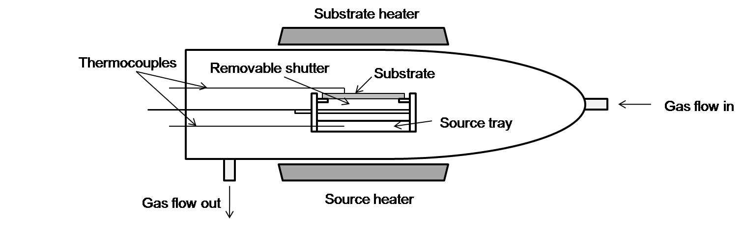

*Figure 3.1: Schematic diagram of the close-space sublimation chamber.*

The system clearly allows the user to control the heat gradient between source and substrate using the two heaters, although the source heater is notably more powerful. A heat shield above the quartz tube chamber is used to attain more uniform heat distribution, but the source must be at a higher temperature than the substrate or else adsorption onto the substrate is not possible. The set-up enables the user to pump the chamber down to vacuum, to create an ambient pressure of H2, N2 or O2, or to control continuous gas flows.

*RF Sputtering*

In short, sputtering involves the bombardment of a source target with energetic, non-reactive ions to knock out atoms which subsequently condense onto a substrate. The ejection process occurs as a result of momentum transfer between the impinging ions and the atoms of the target being bombarded. The energetic ions are typically supplied in the form of an Ar+ plasma. RF sputtering uses a high frequency alternating potential to neutralise surface charges periodically with plasma electrons which have a higher mobility than the positive ions. This enables the sputtering of insulating materials. RF sputtering may also be used to sputter-etch substrates by placing them on the cathode. To obtain high sputter yields, magnetic fields can be used to trap electrons close to the surface of the target. In this investigation an AJA Orion Phase II-J dual chamber sputtering system was used, with each chamber able to accommodate a maximum of five unbalanced RF magnetron guns, in which the targets are mounted.

*Thermal Evaporation*

During the cell fabrication process, the deposition of CdCl2 prior to treatment, and the deposition of the Au back contacts are both done via thermal evaporation. This involves vaporisation of a solid material by heating it to sufficiently high temperatures and condensing onto a cooler substrate112. Typically, heat is applied electrically to a filament boat that holds the material. Deposition rate is monitored by a quartz crystal microbalance, which measures the change in frequency of a quartz crystal resonator and equates it to a change in mass.

***3.1.1: Characterisation Methods***

*J-V and EQE*

For J-V measurements, devices are placed under an Oriel 81160 AM1.5 solar simulator, and a bias is applied by a Keithley 2400 source meter. The generated current is measured and plotted against applied bias to create a J-V curve. Typically, the bias range would be -1V to +1V. Performance parameters are extracted from the J-V curve as described in Section 2.1.3. EQE measurements record the current generated under monochromatic illumination as a function of wavelength. Major7 describes the ideal ‘top-hat’ response of a CdTe/CdS device, a result of current predominantly being photo-generated in the region between the CdTe and CdS band gaps, and he explains any deviations from such ideal behaviour.

*SEM*

A Hitachi SU70 scanning electron microscope was used for high resolution secondary electron imaging and elemental analysis via energy dispersive X-ray spectroscopy. A highly focussed beam of electrons is fired from an FEI XL30 Schottky field emission gun. A number of various interactions occur at the sample, such as X-ray emission and cathodoluminescence, but it was predominantly secondary electron emission that was used for imaging in this investigation. Both plan view and cross-sectional images could be taken, with the option to tilt the sample at any desired angle. The system allowed magnifications of up to × 800k. See Goldstein *et al.* for a comprehensive review of scanning electron miscroscopy. 113

**Section 4: CdTe/CdS Devices by Close-Space Sublimation (CSS)**

This section describes the growth, processing and characterisation of complete planar solar cells fabricated by close-space sublimation (CSS).

***4.1.1: Experimental procedure***

* Tec 15 GlassTM supplied by Pilkington was used for the substrates. The glass is covered with a layer of transparent conducting oxide, with a sheet resistance of 12 – 14 Ω/.
* The close-space sublimation system can accommodate one 5 cm x 5 cm sample at a time. Prior to growth, these samples were scrubbed with de-ionised (DI) water with a nylon brush, and blow dried with N2.
* The CdS (99.999% purity) window layer (~ 150 nm) was grown for 1 min, using a source temperature of 650ºC. Gas flows of O2 (9 ml/min) and N2 (6 ml/min) were present during growth.
* The sample was transferred to a separate chamber for CdTe growth. The CdS layer was subject to a 20 minute anneal at 480ºC under flows of 100 ml/min N2 and 100 ml/min of H2.
* CdTe (99.999%) was grown for 30 minutes, at 615ºC under a 17.5 Torr N2 ambient. This yielded an approximate thickness of 4 – 5 µm.
* A second stage of CdTe growth was performed under a 350 Torr N2 ambient for 1 minute. The purpose of this step was to introduce a thin layer of small grains in an attempt to fill any present pin-holes within the larger-grained film.
* The sample was rapidly cooled under 350 torr N2
* It was then wet-etched in a nitric phosphate (NP) solution for 15s, rinsed in DI water and blow dried with N2.
* A 200 nm layer of CdCl2 was thermally evaporated onto the CdTe at 500ºC under vacuum (10 - 5 Torr). The sample was then annealed in air at 400ºC for 23-25 minutes.
* A second NP etch was applied for 10s to clean the back surface.
* 70 nm Au was deposited to back-contact the sample, in an array of 5mm x 5mm contacts.

***4.1.2: Performance characterisation***

It is standard procedure at Durham to CdCl2 treat the CSS samples for between 23-25 minutes, and so to ascertain the reproducibility of the process, the performance of 90 working contacts (devices), taken from 7 separately grown samples, were measured following such treatment. A frequency plot of efficiencies is illustrated in Figure 4.1. An average of 5.8 ± 2% was achieved, with a peak efficiency of 10.6%. Devices treated for shorter periods (~ 10 minutes) or longer periods (~ 35 minutes) performed poorly, achieving *η* = 1.3 ± 0.7% and *η* = 2.2 ± 1.0% respectively, owing to non-optimised levels of CdTe/CdS intermixing, and are not included in the distribution that is shown in Figure 4.1. J-V and EQE curves of the best performing device are shown in Figure 4.2a and 4.2b. A relatively wide-distribution of efficiencies is observed, and there was little reproducibility of the high performance devices (*η* > 10%). Series and shunt resistances of the best performing device can be estimated from the gradients in the forward and reverse biases respectively, as stated in Section 2.1.3. These were *RS* = 3.2 Ω.cm2 and *RSH* = 1300 Ω.cm2

The J-V of the best performing device was fairly typical, aside from the evident rollover of the slope in the forward bias. This is commonly associated with a poor back contact, whereby a Schottky barrier exists as a result of CdTe having a higher work function than Au. This behaviour was noted for a large proportion of the devices. The EQE response shows the typical top-hat function, although the gently decreasing slope throughout the bulk response region may result from a CdTe layer that is too thin. The longer wavelengths are able to transmit through the device without being absorbed. The sudden jump in response at 400 nm is a result of a calibration error in the system.

Graph2.tif

*Figure 4.1: Distribution of efficiencies of 90 close-space sublimation grown devices.*

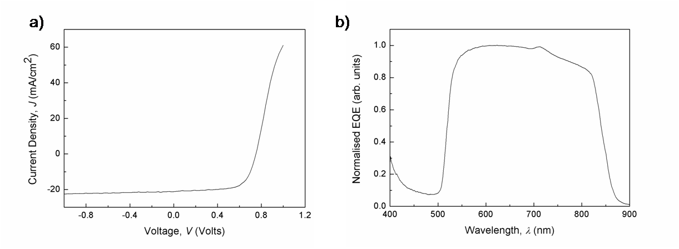

*Figure 4.2: a) J-V and b) Normalised EQE plots for the best performing cell grown by close-space sublimation.*

*Discussion*

There are a number of stages involved in the fabrication of a device, during which random errors in the procedure can occur, so it is difficult to ascertain the primary causes of the apparent lack of performance reproducibility. As mentioned, the rollover of the J-V curve in the forward bias is indicative of a poor back contact. The NP etch and subsequent CdCl2 treatment is in place to obtain a *p+* Te rich layer at the back surface to thin the Schottky barrier and promote tunnelling based charge transport. It is clear that the procedure has been insufficient in this case. It can be speculated that device performance is sensitive to this procedure, and so slight variation to the repetition of this step could result in noticeably variable performance. See Al Turkestani for a comprehensive study of the dependence of device performance and Schottky barrier height on the etching procedure12.

Non-uniformity of device fabrication also arises from the close-space sublimation technique. Films are typically deposited thicker in the centre of the sample relative to the edges (Figure 4.3). The best performing device was found at the edge of a sample, which would explain the typical EQE response for a thin absorber layer. This would suggest that at the centre, the CdTe layer is too thick, as poorer devices were found in the centre of that sample. There is no systematic correlation between device performance and positioning of its contact on the sample however.

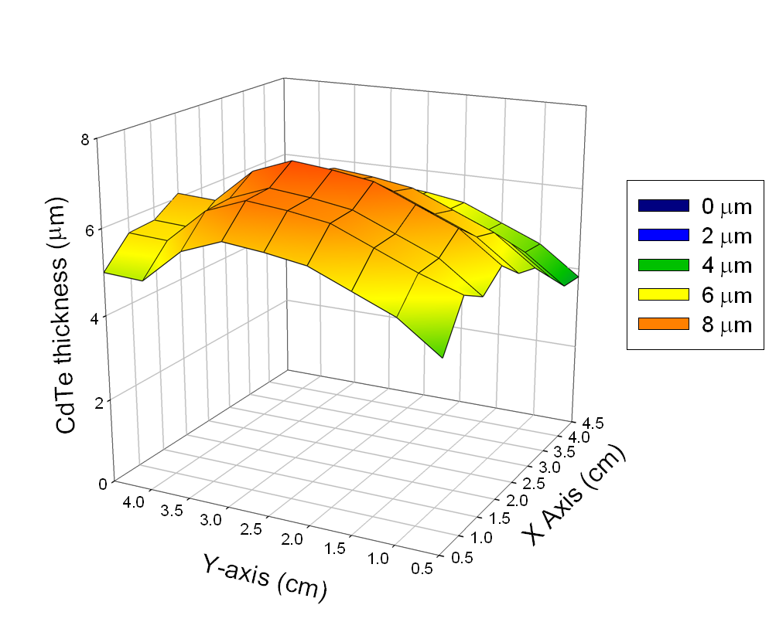

*Figure 4.3: Profile of CdTe thickness across a 5 cm x 5cm sample, deposited by close-space sublimation.*

**Section 5: CdTe/CdS Devices by Sputtering**

In this section the growth, processing and characterisation of all-sputtered CdTe/CdS/ITO/glass solar cells is presented. As mentioned in Section 2.3.2 the present record performance for such cells is 14.0% and the following work represents the initialisation of a new baseline process for European PV research.

***5.1.1: Experimental procedure***

*Film Growth*

* Low iron soda-lime glass substrates (Pilkington Opti-WhiteTM, > 90% transmission in the visible), 10 cm x 10 cm x 3 mm in size, were cleaned by scrubbing using a nylon brush and DI water, followed by an isopropyl alcohol rinse and N2 blow dry.
* The substrate surfaces were then plasma etched for 10 mins in the first sputtering chamber prior to the transparent conducting oxide deposition.
* Tin doped indium oxide (ITO) was chosen for the front contact, the target being of composition In2O3 (90%)/SnO2 (10%) (99.99% purity, AJA). Sputtering at 60 W under 1 mTorr of Ar and with the substrate held at 400°C generated layers of 230 nm thickness (having a sheet resistance of

6 Ω/□). Their resistivities were 1.2 x 10-4 Ω.cm and optical transmission was > 90% over the visible range.

* A high resistivity (> 10-2 Ω.cm, 50 nm thick) layer of ZnO was sputtered from a ceramic ZnO target (99.99% Pi-Kem) at a power of 100 W, a pressure of 5 mTorr and at room temperature.
* The substrate was then transferred under vacuum to the second chamber, where a 200 nm layer of CdS was deposited at 60 W, under 5 mTorr Ar and at a substrate temperature of 350°C. A 3% partial pressure of trifluoromethane (CHF3) was incorporated during growth to improve the quality of the CdS film. According to Romeo *et al.* the decomposition of CHF3 in the plasma introduces F- ions that back-sputter the growing CdS film which helps to remove voids within the material and hence increases the film density.101
* A 3.5 *µ*m thick layer was sputtered from a CdTe target of (99.99%, AJA) at 70 W, under 5 mTorr of Ar and at a substrate temperature of 350°C. A growth rate of ~7.3 nm/min was achieved.

*Post growth treatment*

* The finished 10 x 10 cm plates were then quartered, and onto each sample a 200 nm layer of CdCl2 was deposited via a thermal evaporation system. Following preliminary experiments to determine the optimum treatment time, each sample was annealed in a tube furnace for 9-11 mins in air at 390°C. All samples were then rinsed in warm DI water to remove any excess CdCl2 and dried before depositing a grid of 5 mm x 5 mm square gold contacts, 100 nm in thickness. A total of 201 working contacts (devices) were generated from three 10 x 10 cm plates.

***5.1.2: Performances of three distinct populations***

The distribution of efficiency values from the 201 devices and typical J-V and EQE curves are shown in Figures 5.1, 5.2 and 5.3 respectively. Three distinct populations of devices were identified in Figure 5.1, and these were attributed to being under-treated, optimised and over-treated with CdCl2. Examples of the *η*, *VOC*, *JSC*, *FF* and series and shunt resistance values for these populations are listed in Table 5.1.

Graph2.tif

*Figure 5.1: Distribution of efficiency of 201 5mm x 5mm contacts taken from 12 separately processed samples. An average of 8.6 ± 2.2% (1 S.D) was obtained (not including over-treated contacts).*

Graph2.tif

*Figure 5.2: J-V curves for under-treated (η = 3.1%), well treated (η = 9.3%) and over-treated (η = 2.5%) devices.*

Graph1.tif

*Figure 5.3:* *Normalised external quantum efficiency curves for under-treated, optimised and over-treated devices. Curves are normalised to their individual peak values. The under-treated device shows a typical response curve for a buried junction.*

|  |  |  |  |  |
| --- | --- | --- | --- | --- |
|  | ***Under-treated*** | ***Over-treated*** | ***Optimised*** | ***Best contact*** |
| ***η (%)*** | 3.09 | 2.20 | 9.30 | 11.37 |
| ***VOC (V)*** | 0.69 | 0.77 | 0.80 | 0.80 |
| ***JSC (mA/cm2)*** | 10.17 | 6.44 | 19.69 | 25.00 |
| ***FF (%)*** | 43.92 | 44.68 | 58.66 | 56.74 |
| ***RSeries (Ω.cm2)*** | 23.57 | 22.10 | 8.39 | 7.61 |
| ***RShunt (Ω.cm2)*** | 641.03 | 1113.59 | 731.69 | 2011.67 |

*Table 5.1: Performance characteristics of typical under-treated, over-treated and optimised devices, along with the best performing device.*

In preliminary experiments the shorter CdCl2 annealing times used (~ 5 mins) typically led to the low device performance associated with under-treatment. However, for devices annealed in the optimum time window (9-11 min) it was often found that some parts of a given 5 x 5 cm sample were visibly degraded. The low performance of these parts was attributed to over-treatment. The best cells were associated with specific regions of the samples and these are now described.

*Optimised devices*

The main group of cells in the distribution shown in Figure 5.1 is for high performing devices having an efficiency of 8.6 ± 2.2%. EQE results for a typical cell from this group (Figure 5.3) indicate that the junction is at an optimised position, with high response over the range 550 – 800 nm. Poor response in the sub 500 nm range may be attributed to absorption in the CdS, which was 200 nm thick.

The best cell in the group had the following parameter values: *η* = 12.4%, *VOC* = 0.82 V, *JSC*= 24.9 mA.cm-2 and *FF* = 61%. Its high performance was associated with a relatively low *RS* (7.6 Ω.cm2) and a high *RSH (*2011Ω.cm2), leading to good rectification and a high *FF*.

*Over-treated devices*

As mentioned above, over-treatment was clearly identified since there was visible physical degradation of the layers. In particular, the films showed signs of bubbling and exfoliation, and had poor adhesion. Viewing from the glass side revealed discolouration from the more usual black to an orange-grey. The efficiencies (3.3 ± 1.3%) were correspondingly degraded.

Although the shapes of their EQE curves were comparable to those for optimised cells, their magnitudes were reduced, leading to reduced *JSC*. (N.B. the curves in Figure 5.3 are normalised to allow comparison of the curve shapes). Another factor contributing to the poor efficiency of the cells is the series resistance which is typically > 2 × *RS* for the optimised cell population.

*Under-treated devices*

Short CdCl2 processing times (~ 5 mins) lead to the J-V and EQE curves shown in Figures 5.2 and 5.3. The EQE curve shape is typical for buried junction behaviour, and this is consistent with the depth of diffusion being insufficient to form a junction at the correct position in the CdTe.

The population of under-treated cells shown in Figure 5.1 was for cells on the 5 mm x 5mm device plates which were treated for 9-11 minutes, i.e. the same runs as for the main series of samples. They were identified on the basis of their low efficiency and/or low *FF* (≤ 35%), since they were visibly indistinguishable from the optimised regions of the material. The efficiency was 4.4 ± 1.6%, the low performance being due to a relatively low *FF* together with low *JSC* and *VOC*.

***5.1.3 SEM cross section and EDX analysis***

Part of an optimised device was fractured so that a cross-sectional scanning electron microscope image could be taken, as shown in Figure 5.4a. Clearly, the bulk of the device is the absorbing CdTe layer. The ITO layer is visible, exhibiting a small grain structure. The CdS layer is not clear as a result of intermixing with the CdTe. EDX analysis gives qualitative data of the elements present at certain depths (Figure 5.4b). The apparent diffusion of indium towards the bulk of the device suggests the thickness of the ZnO buffer layer is insufficient. Of course, due to the nature of EDX analysis, there is inevitably a limit to the precision with which elements can accurately be resolved at each spatial location.

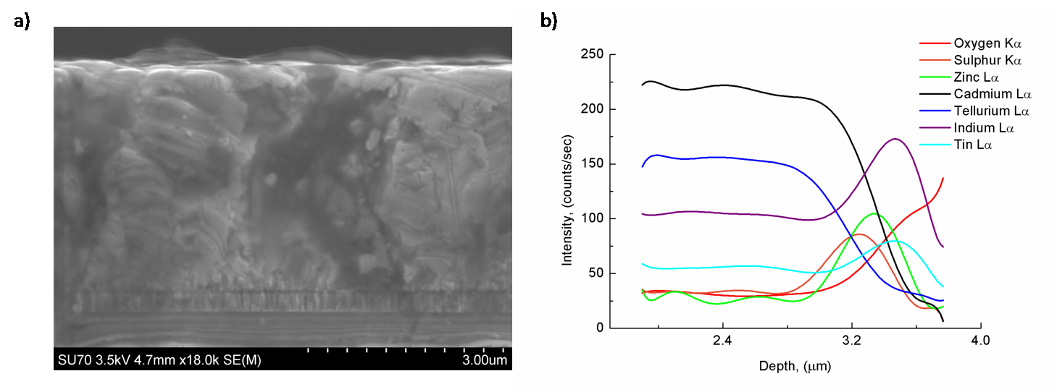

*Figure 5.4: a) Cross-sectional SEM image of an optimised all-sputtered CdTe/CdS device. b) Associated EDX linescan showing the presence of certain elements as a function of depth*

***5.1.4: Discussion***

It has been shown that the all-sputtering process is capable of producing excellent device results for the CdTe/CdS/ZnO/ITO/glass structure, with efficiencies as high as 12.4%. This is a baseline from which further optimisation and device design improvements may be made.

It was recognised that the process is particularly sensitive to the CdCl2 annealing step. This can lead to profound differences over a 5mm x 5mm plate, leading to three separate populations of cell performances, as shown in Figure 5.1 and described above. The sensitivity is considered to be unlikely to result from variations in the CdCl2 thickness, since an excess thickness of it (~ 200 nm) is applied over the entirety of each plate. It is more likely that the differences arise from temperature non-uniformity within the tube furnace. (An analytical treatment of the radial temperature distribution in tube furnaces is given in reference 110).

The response of the CdTe films to CdCl2 treatment is known to take the form of Cl-in-diffusion, re-crystallisation and grain growth. Moutinho *et al.*114 demonstrated that such metallurgical changes are accelerated in materials having small grains and high strain. Since these are characteristics of sputtered material (typical grain size ~ 200nm), extreme sensitivity to minor temperature variations is expected. Moreover this degree of sensitivity is neither observed nor expected for CSS-grown material which has larger grain size. There is considerable scope to use this baseline process as a starting point for further improvements in the device and processing design. For example, the CdS used here was ~ 200 nm thick; reducing this will enhance the EQE in the sub 500 nm region. It has also been shown that the ZnO buffer layer may be required to be thicker, so to reduce indium diffusion to the junction.

**Section 6: CdTe Nanowire Growth**

Here, the initial attempts at growing Au-catalysed CdTe nanowires on Si $〈111〉$, is documented. To the author’s knowledge, no such work has been reported. In the vapour-liquid-solid process, the distribution and size of nanowires is dependent on that of the catalyst particles52. Consequently, an initial study was carried out to understand the formation of Au nanodots, by annealing a thin Au film. This study is reported in Section 6.1. (Section 2.2.2 describes the process of a thin film agglomerating into an array of nanoparticles that wet the surface). Subsequent growth of the nanowires themselves, following optimisation of the pre-growth annealing conditions, is reported in Section 6.2.

**6.1 – Self assembly of Au nanodots by annealing**

***6.1.1: Experimental procedure***

* 15 mm x 15 mm substrate samples were cut from 3” Si $〈111〉$ wafers of 380 μm thickness using a diamond scribe. The wafers were polished on one side and are p-doped with boron.
* Samples were scrubbed with DI water using a nylon brush and blow-dried with N2.
* A thin film (1 – 5 nm) of gold was deposited by thermal evaporation onto the polished side of the substrates. A Univex 300 coating system was used, and the thickness was monitored by a Maxtek TM-400.
* The samples were then transferred into the CSS chamber, and placed on a 50 mm x 50 mm piece of Si that is used to distribute heat evenly.
* The N2 ambient was controlled using the automatic system, and experiments operated in the range, vacuum – 600 Torr.
* Both the bottom and top heaters were used in an attempt to obtain a uniform heat distribution. The timer was started when the bottom thermocouple (at the source) reached the desired temperature. The substrate thermocouple would typically reach the temperature approximately 30 seconds later.
* After the desired annealing period, the heaters were simply turned off. There was no rapid cooling of the samples.
* Plan view SEM images of each sample were taken using secondary electron imaging. The average diameter of the nanodots was measured using the image analysis software, *Image ToolTM*. The density of the dots, surface coverage of the substrate and distribution of dot sizes could also be calculated using the software. For each sample, data was taken from three separate substrate locations (images of ×200k mag.) and averaged.

***6.1.2: Results and Discussion***

*Temperature Dependence*

Samples with an initial film thickness of 5 nm were annealed for 30 minutes under an N2 ambient pressure of 100 Torr, at various temperatures (300ºC – 475ºC). Figure 6.1a shows the temperature dependence of the average nanodot diameter. The surface coverage variation is illustrated in Figure 6.1b.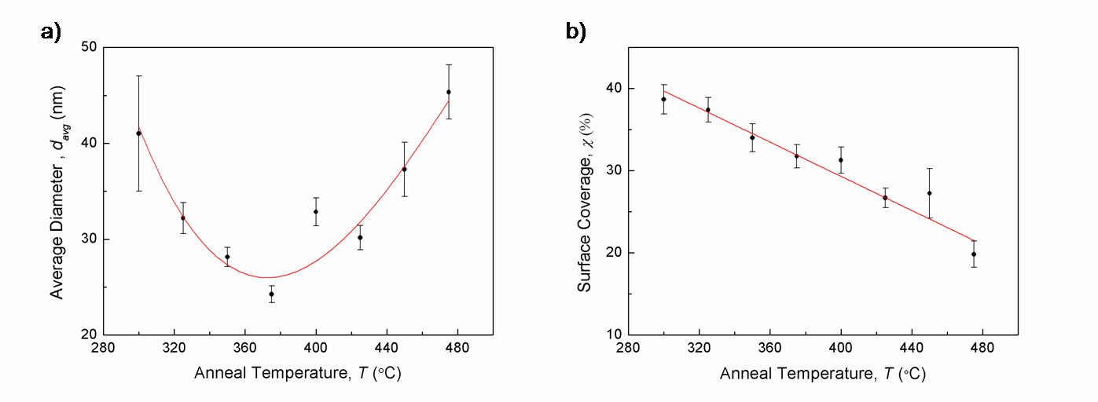

*Figure 5.1: a) Average diameter of nanodots as a function of annealing temperature, fitted with a 3rd order polynomial. b) Associated change in surface coverage, revealing a linear dependence in this data range.*

The formation of nanodots from a uniform film upon annealing was described in Section 2.2.2. Briefly, holes form in the film, and these grow in a fractal form. As islands become isolated, the effect of higher temperature is to promote surface diffusion and island coalescence. This results in a lower density of islands, these being larger and of greater height. The trend of Figure 6.1a is consistent with this pattern: from 280 – 360ºC, the increased break-up of the layer yields smaller dots. Higher temperatures still encourage the coalescence mentioned above. The accompanying decrease in surface coverage is shown in Figure 6.1b and is discussed further later in this section. An illustration of the development of the film is shown through SEM images in Figures 6.2a – c. It is expected, but not explored here, that annealing at a given temperature for increasing time periods will yield a similar development in film/dot features.

A minimum average island diameter, *davg*, of 24.26nm was found at a temperature of 375°C (which is notably roughly the Au-Si eutectic point). This sample also had the smallest distribution of island sizes, with a standard deviation of 8.2. At lower temperatures there is a wide size distribution as the process whereby the fractal voids grow and meet is incomplete. The distribution is also wider at higher temperatures during the coalescence regime. In theory, at higher temperatures still, continued island coalescence will ultimately result in the presence of just one large island, as this is energetically favourable.

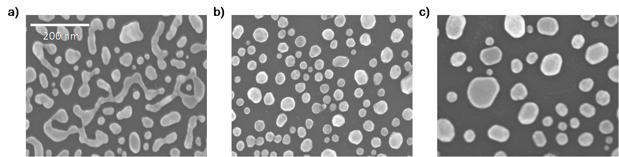

*Figure 6.2: ×200k magnification SEM images at a) 300°C, the breaking up of the film is incomplete, b) 375°C, an array of Au nanodots, c) 475°C, the dots have begun to coalesce forming larger dots. A 13kV beam electron beam was used and the scale bar is the same for all images.*

*The development of the surface coverage*

We can make a very rough estimate of how surface coverage *should* change, as the annealing temperature increases, by considering two separate contributions. Firstly, consider a substrate with an array of cubic islands (assumed for simplicity). By the time pairs of islands have coalesced, leaving half the number of islands, and assuming that the aspect ratio is maintained following coalescence, the surface coverage should reduce by 20%. On the other hand, above the eutectic temperature (363°C), the formation of Au-Si alloys will result in a change to the wetting angle, reflecting interfacial energy changes. Ressel *et. al*115 report that the wetting angle of these Au-Si alloys increases linearly with temperature, which should contribute an increase to the surface coverage. To apply this to our experimental data, we can compare the surface coverage after a 375°C anneal and a 425°C anneal (each at a pressure of 100 Torr), as the latter sample consisted of roughly half the number of islands as the former. The surface coverage actually decreased from (32 ± 2) % to (27 ± 2) %; a (16 ± 2) % reduction. By examining the Au-Si phase diagram, the at. % of Si merely increases from ~ 19% to ~ 22% following a temperature increase of 375°C to 425°C, and so it is apparent that the minimal increase in wetting is insufficient to prevent a decrease of the surface coverage, via island coalescence (seen in Figure 6.1b).

*Varying Pressure*

The same temperature range was investigated with an N2 ambient of 50 Torr (Figure 6.3a). It appears as though the same parabolic trend is replicated but the change in pressure shifts the curve to lower values along the x axis. Within this temperature range, much of the region in which the diameter decreases is cut off. The minimum average diameter is found at a lower temperature (24.9 nm at 325°C) than that for a 100 Torr ambient. At lower ambient pressure the particles may be more susceptible to surface diffusion, possibly as liquid-like behaviour is able to occur at lower temperatures. For samples annealed under 200 Torr of N2, the curve is shifted to higher temperatures (Figure 6.3b) and the minimum average diameter, *davg*, is obtained at 400ºC. A three-dimensional plot combining the data from Figures 6.1a, 6.3a and 6.3b, along with a plot showing the pressure dependence of nanodot size is displayed in Figure 6.4. The polynomial fits to the data were used, as opposed to the raw data as the error bars would have made the graph unclear.

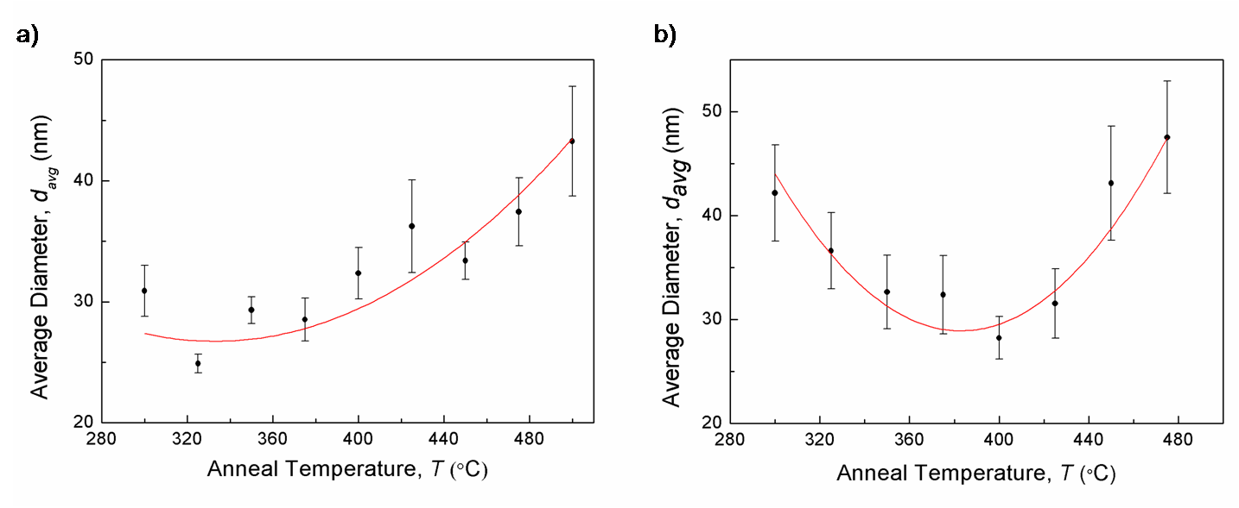

*Figure 6.3: Temperature dependence of nanodot diameter when ambient N2 pressure is a) 50 Torr and b) 200 Torr.*

figure 6.4.TIF

*Figure 6.4: 3D plot combining data for temperature dependence and pressure dependence of the average nanodot diameter.*

*Varying film thickness*

By reducing the pressure in the chamber, the film was able to break up at lower temperatures. It did not however yield a reduction in the minimum obtainable average dot diameter. To do this, the initial film must be grown thinner. Figure 6.5 shows the strong positive dependence that the particle size has on the initial film thickness. This is also illustrated in Figure 6.6. In all the SEM images, it is interesting to note that the particles are consistently brighter at their edges than at their centre. This is because at the edges of a spherical drop, there is greater curvature and so these regions have more surface area to contribute to the signal. Secondary electron imaging is very surface sensitive.

thickvar.tif

*Figure 6.5: Dependence of average dot diameter on the initial Au film thickness.*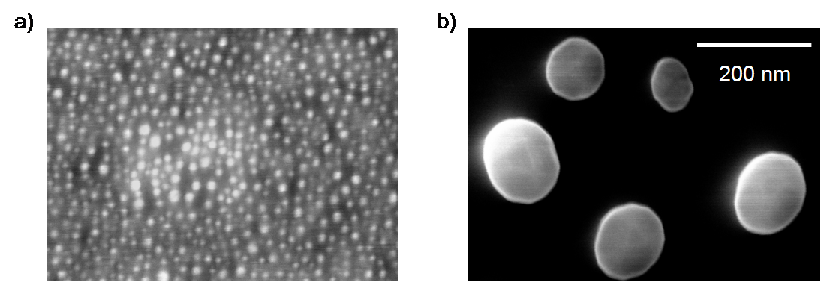

*Figure 6.6: a) 20k × magnification SEM image of Au dots resulting from annealing a 2nm thick film for 30 minutes. T = 400C, P = 100 Torr. b) Much larger dots result from annealing a 10nm thick film. The scale bar is the same for both images.*

**6.2 – Nanowire growth by close-space sublimation**

The pre-growth annealing conditions used were those that yielded a small average diameter and relatively narrow size distribution. The samples grown at higher pressures demonstrated a markedly wider distribution, and at lower pressures the agglomeration of Au nanoparticles occurs more rapidly and so is harder to control. Initial runs were therefore done at 100 Torr, at which the minimum average diameter was obtained at 375ºC. The size distribution under these conditions was still larger than ideal (Figure 6.7) but this could provide useful information on the dependence of wire diameter on catalyst diameter. A slightly thinner film of Au was deposited (4nm) as work by Cirlin116 *et al.* suggests that thinner films are beneficial to nanowire growth. However, the effect of annealing films of sub-nanometre thicknesses was unknown, and so such ultra thin films weren’t used in preliminary experiments.

Graph2.tif

*Figure 6.7: A wide distribution of nanodot sizes is typical using the self-assembly process. This data set was taken for a sample annealed at T = 375ºC, P = 100 Torr for 30 mins.*

***6.2.1: Experimental procedure for wire growth***

* The source tray is below the substrate holder, so samples must be facing down during growth. As a result a stainless steel mask was made to place the samples on. An area of 14 mm x 14 mm of each sample is exposed to the source.
* The pre-annealing step is carried out using both heaters for 30 minutes, with the shutter kept in. T = 375ºC, P = 100 Torr
* Following annealing, the source heater is raised to 550ºC, and the substrate heater is turned off. Nonetheless, the substrate reaches a temperature of ~ 460ºC. (Preliminary experiments revealed that at a source temperature of 550ºC, 40 nm/min of CdTe is deposited on glass, although inevitably deposition rate will vary for different substrates.)
* The pressure is kept at 100 Torr.
* When the source temperature reaches 550ºC, the shutter is opened for 20 minutes growth.
* After closing the shutter, the source heater is turned off and there is no rapid cooling.

***6.2.2: Preliminary results and discussion***

Figure 6.8a is an SEM image (×18k mag.) of a sample (S1) grown using the conditions described above. Figure 6.8b is a cross section of a sample (S2) grown at the same conditions, but for only 10 minutes. There are evidently columnar structures, uncharacteristic of typical thin film growth, seen in Figure 6.8a. These are of much greater diameter (~ 300 nm) than the Au catalysts (~ 30 – 50 nm) however. It is likely that with such a great temperature gradient (TSOURCE = 550ºC, TSUB= 460ºC), the growth rate is too rapid to allow stable VLS growth, and lateral growth on the sidewalls of nanowires occurs. Furthermore, the substrate temperature has to be sufficiently high to allow diffusion of adatoms from substrate to catalyst. The cross-section of a sample grown for 10 minutes (Figure 6.8b) reveals greater defined wire-like structures, of smaller diameter (~ 100 nm). Less material has been deposited at this stage, and lateral growth is limited. However, their random orientation and the presence of crystal facets, suggests that growth conditions are far from optimised. One wire in this image is observed to deform along its length. This was the effect of the 10kV electron beam.

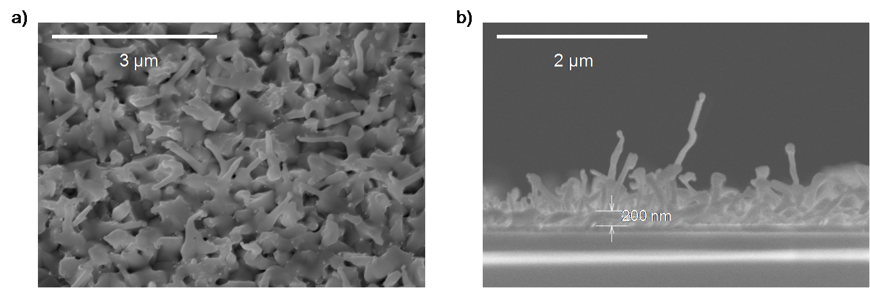

*Figure 6.8: a) Sample S1: Plan view of sample grown for 20 minutes at 550°C, under 100 Torr of N2. b) Sample S2: Cross-section of sample grown for 10 minutes under the same conditions.*

Following analysis of cross-sectional images, it was determined that a common problem with all samples was the presence of an irregular CdTe film, ~ 200 nm thick, shown in Figure 6.8b and more clearly in Figure 6.9. Here, CdTe growth lasted for only 2 minutes, and so it is likely that some growth is occurring during the stage whereby temperature is ramped to the deposition temperature, even with the shutter closed. This irregular film consists of ‘nano-hills’, many of which exhibit what appears to be a Au particle at their peak. This is the result of CdTe successfully precipitating underneath a Au particle following super-saturation of its liquid-like alloy. Conditions are however not correct for purely nanowire growth, possibly due to the substrate temperature being too low. CdTe may sublimate at 500ºC, and escape round the sides of the substrate mask, or even from its underside. This is confirmed by a ‘dry’ run (sample S4), whereby the temperature was taken to 550ºC and dropped back down again, with the shutter closed throughout. Figure 6.10a reveals that CdTe deposition does indeed still occur. As a preventative measure, the ambient pressure of the chamber can be raised to 500 Torr when the temperature is ramped up. To determine the effect of this step, a second ‘dry’ run was carried out (sample S5), and the use of the higher pressure was seen to quench any unwanted ‘pre-growth’ (Figure 6.10b). As a result, for all subsequent runs, a high pressure is applied when the temperature is raised between the annealing and growth periods. When the deposition temperature is reached, the shutter is opened, and the pressure dropped to 100 Torr.

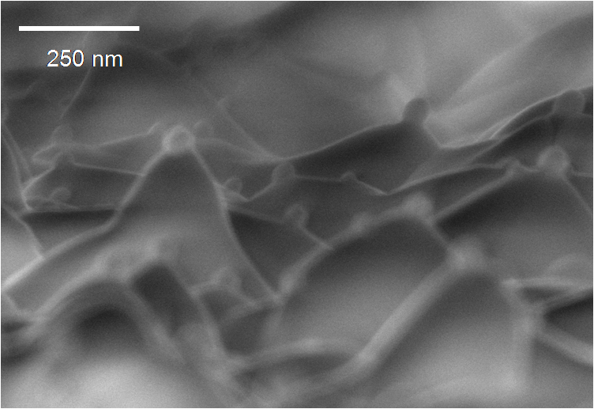

*Figure 6.9: Sample S3: The presence of ‘nano-hills' on a sample grown for only 2 minutes suggests that deposition occurs before the growth period, even when the shutter is in.*

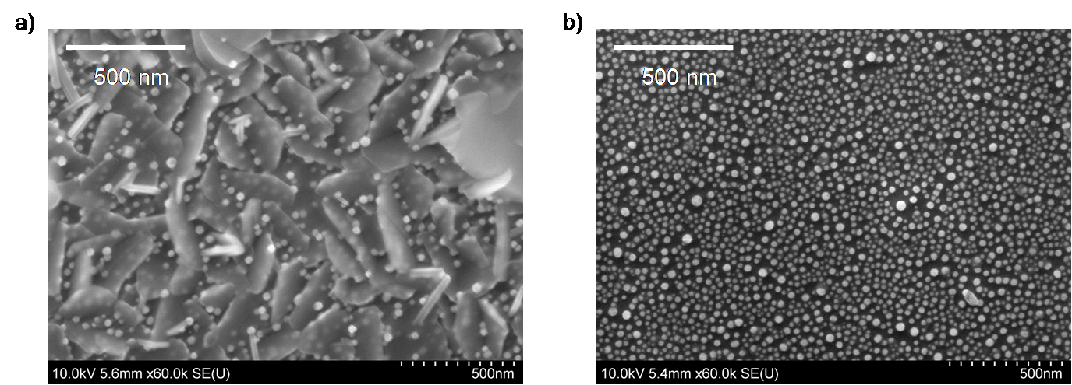

*Figure 6.10: Sample S4: After raising the temperature to 550ºC with the shutter in, there was still some CdTe deposition. b) Sample S5: This could be prevented by introducing 500 Torr of N2 to the chamber when raising the temperature.*

***6.2.3: Secondary results following procedure changes***

The next sample (S6) was grown for 20 minutes, with the substrate temperature set at 500ºC (*TSOURCE* = 550°C). The purpose of this change was to promote surface diffusion on the substrate and specifically to reduce the growth rate. By garnering greater control over growth, it was easier to determine whether or not CdTe nanowires can be grown using these methods. High aspect ratio nanowires are observed (Figure 6.11) but are sparsely spread across the substrate. Typical dimensions for one of the more developed wires are; height ~ 4 μm, diameter ~ 50 nm, and aspect ratio ~ 80.

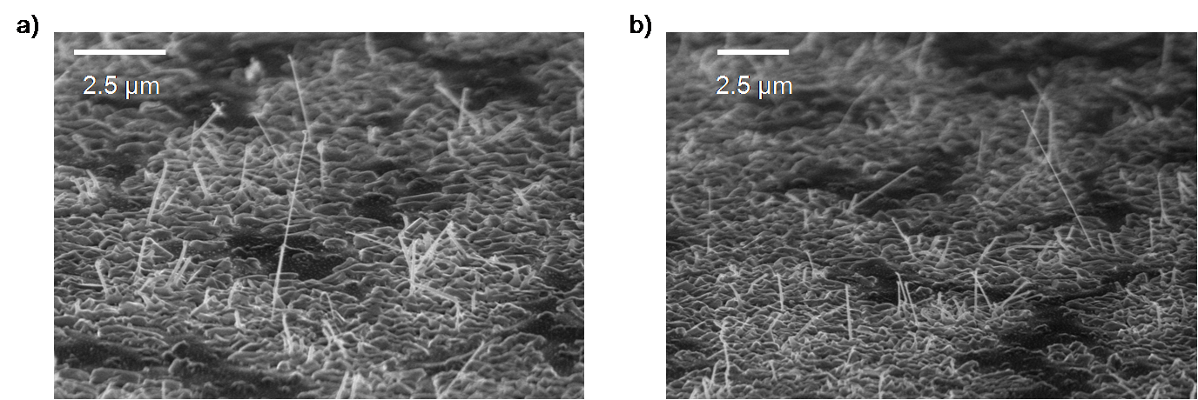

*Figure 6.11: Sample S6: High aspect ratio nanowires are sparsely found across the substrate. TSOURCE was maintained at 550ºC, but TSUB was set to 500ºC. Growth was for 20 minutes, under 100 Torr of N2.*

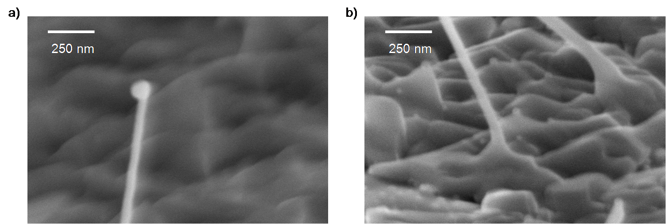

*Figure 6.12: Sample S6: a) The Au particle remains at the top of the nanowire, as predicted by the VLS theory. b) The nanowires appear to nucleate from the nano-'hills'.*

The end of one nanowire is shown in Figure 6.12a, and as expected from the vapour-liquid-solid theory, the Au particle remains at the top. Interestingly however, the catalyst has a diameter almost twice that of the wire itself. It is possible that not the entirety of the Au catalyst becomes liquid and so the liquid-solid interface has a smaller area than expected. It has also been seen by Hannon55 *et al.* that neighbouring Au particles can migrate up the sidewalls of the wire and coalesce with the particle at the tip.

Despite the measures taken to prevent growth of the irregular film of ‘nano-hills’, it is apparent that it still forms. The wires actually appear to nucleate from the Au catalysts that rest at the peaks of the hills (Figure 6.12b). This explains the random orientation of the wires, as if they had nucleated from Au dots on a bare Si $〈111〉$ substrate, it is expected that the wires would grow vertically.

When the annealing temperature is set to 375ºC, the heater overshoots to approximately 390ºC, and reaches equilibrium at 375ºC after 5 minutes. The annealing temperature for the next sample (S7) was therefore reduced to 360ºC. The growth conditions were kept the same as the previous sample, but the growth period was extended to 30 minutes. A dense array of highly defined CdTe nanowires were observed on this sample (Figure 6.13 and 6.14a), but it appears as though they only grow on the perimeter of the sample. Figure 6.14b is a low magnification image of the sample. In the bright region growth occurs, but in the centre, only the rough film is seen.

Using the same conditions, another sample was prepared, but this time with a much more rigorous cleaning process prior to Au deposition. The sample was scrubbed with DI water and dried with N2, given an ultra-sonic bath in DI water for 20 minutes, in acetone for 20 minutes and in isopropanol for 10 minutes. It was finally rinsed in DI water and again dried with N2. The extra measures appeared to have no effect on the results however, suggesting the original preparation procedure is sufficient.

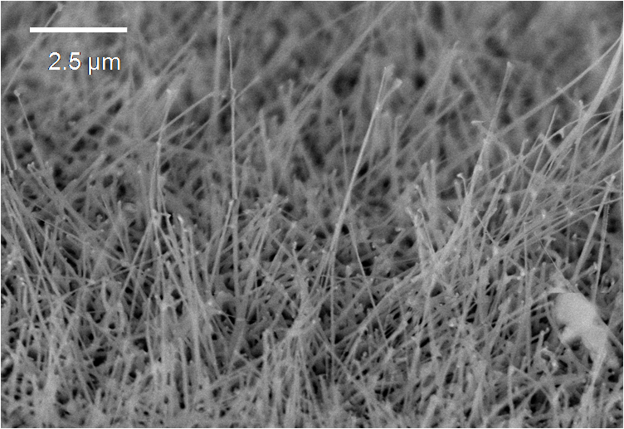

*Figure 6.13: Sample S7: High density of very high aspect ratio CdTe nanowires grown for 30 minutes on Si $〈111〉$ substrate using Au catalysts. TSOURCE = 550ºC, TSUB = 500ºC, P = 100 Torr.*

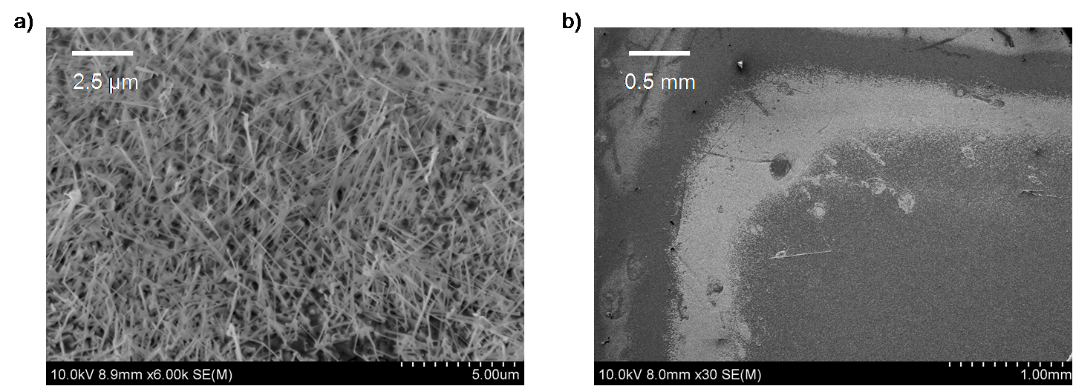

*Figure 6.14: a) Plan view of sample S7. b) Low magnification plan view revealing the narrow perimeter in which nanowire growth occurs (the bright region).*

Figure 6.15 shows the spectrum obtained by energy dispersive X-ray diffraction analysis, from the spherical particle at the tip of one of the wires. There is clearly Au present. CdTe and Si is also detected as it is a plan view image and the beam penetrates through to the surface.

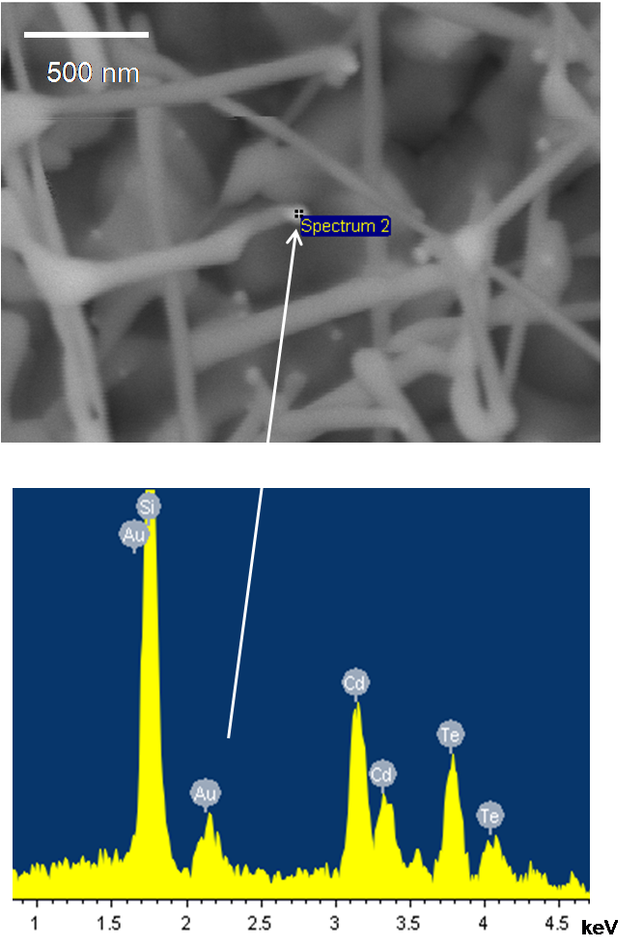

*Figure 6.15: EDX Spectrum confirming presence of Au in the particle at the tip of a nanowire. (Graph shows counts vs. X-ray energy).*

It is clear from the microscope images shown in this section that there is wire formation, but there appears to be discrepancies between the observed growth and that expected by the VLS mechanism. The theory states that growth at the catalyst is more favourable than on the substrate and consequently wires grow from an otherwise bare substrate. In this case however, a roughened, thin film of CdTe is deposited first, from which the nanowires grow. The author suggests a possible growth mechanism dependent on thermodynamic and strain variations.

*Theory of wire formation*

The balance of the surface energies and chemical potentials of the liquid, solid and gas phases may not be correct for successful wire growth in the CdTe/Au/Si regime (Equations 2.14 - 2.16). Instead, a disturbed VLS process may occur whereby these hills form, with the gold catalyst at the peaks. Figure 6.9 is an image of a sample grown for 2 minutes and illustrates this. Also, there is a very large lattice mismatch between CdTe and Si (19.4%) and this has been proven to be detrimental to the quality of nanowires grown by VLS. Chuang *et al.* experimentally determined an inverse relationship between lattice mismatch and the critical diameter, the diameter below which coherent growth can occur117. For InAs nanowires grown on Si (lattice mismatch ~ 11.6%), the critical diameter was as low as 25 nm. The strain present in the CdTe/Si system is therefore likely to greatly disrupt nanowire growth, considering the average Au dot diameter here is in the 30 - 40 nm range. Following the film deposition stage however, the CdTe/CdTe system obviously has no mismatch. The chemical potential of the ‘substrate’ also has a new value after the initial film is deposited, and interfacial energies will change. At a certain film thickness, the thermodynamics become suitable for the VLS mechanism and as illustrated in Figure 6.12b,nanowires nucleate from the gold particles that were present at the hill peaks. The second stage is effectively analogous to cases whereby the source material is the same as the substrate; a scenario proven to be successful for both Si/Au and GaAs/Au systems.

It is paramount that the catalyst and source material can form a liquid alloy at the substrate temperature. At 500ºC the Au droplets can alloy with Si (the at. % of Si in a liquid alloy will be roughly 25 at 500ºC) but it may be the case that this isn’t possible when Si, Au and CdTe are present. Unfortunately the absence of such a quaternary phase diagram in the literature prevents determination of the eutectic temperature. The presence of the Au particles at the hill peaks in sample S7 suggests that liquid alloys did indeed form in the optimum region, but in the centre Au dots are not visible above the rough CdTe film. There is likely to be a temperature gradient from the edge to the centre of the sample as stainless steel (the mask) has a higher thermal conduction coefficient than silicon.

To test these theories, a number of experiments are to be carried out. Firstly, a sample will be made using a higher substrate temperature, so to bring the centre of the sample up to the optimum temperature found at the edges of this sample. Alternatively, temperature distribution could be made more uniform by placing plates on the back of the sample. Secondly, growth of CdTe nanowires on a CdTe film/substrate will be attempted; although it is unclear whether Au nanoparticles can successfully self assemble on a CdTe substrate.

Another limitation to the method used here, is the very likely presence of silicon oxides. Vacuum is broken between the Au deposition and Au annealing stages. The oxide layer will disturb the VLS process, and much recent work on NW growth specifies processes to remove oxides, often using a hydrofluoric acid etch. As CdTe is deposited, the oxide prevents the migration of adatoms to the catalyst, and instead some of the Au is buried. It is evident from Figure 6.10a that the density of Au dots seen above the CdTe film is much lower than observed on the sample in Figure 6.10b.

**Section 7: Conclusion and Future Work**

The initial stage of this work was to attain an understanding of the fabrication methods of CdTe solar cells by close-space sublimation and to learn the techniques to characterise them. Chapter 4 details the processing and subsequent characterisation of 90 devices. An efficiency average of 5.8 ± 2 % was obtained, whilst the reproducibility of high performing cells (> 10%) was determined to be limited by potential processing errors, specifically during the NP etching step. The best device had the following performance values; *η* = 10.6%, *VOC* = 0.76V, *JSC* = 21.1 mA.cm-2, *FF* = 66%.

A baseline for CdTe cells deposited entirely by RF sputtering was obtained. The devices exhibited high sensitivity to the CdCl2 processing step and three distinct populations were deduced based on whether this process had been optimised. For optimised cells an average of 8.6 ± 2.2 % was obtained, with the best device having the following performance values; *η* = 12.4%, *VOC* = 0.82V, *JSC* = 24.9 mA.cm-2, *FF* = 61%. In future work, an alternative to the CdCl2 treatment step will be explored. This will involve an in-situ treatment during the deposition of the CdTe layer.

Within the wider PhD project, a priority will be assigned to fabricating a nanowire based photovoltaic device. This investigation has shown that it is possible to grow CdTe nanowires on a Si substrate, via the vapour-liquid-solid mechanism, using Au catalysts. Initially, the conditions for growing nanowires using the close-space sublimation technique will be optimised. Following this, a window layer of CdS will be deposited via chemical bath deposition, the front contact via sputtering and a back contact on the underside of the Si via thermal evaporation. As the relatively high resistivity of the Si (1 – 30 Ω.cm) may prove to be a great limitation to device performance, the feasibility of depositing nanowires onto other substrates will be explored. Furthermore, by using the sputtering system to grow nanowires, the problems associated with introducing an oxide layer can be avoided. As such, this will also be explored, using various catalysts (Sb, Te, Bi) for nanowire growth.

***Reference List***

1. Gross, R., M. Leach, and A. Bauen, *Progress in renewable energy*, Environment International, 2003. **29**(1): 105-122.

2. *Official First Solar Inc. Web Page*. [cited 2010 19th May]; Available from: <http://www.firstsolar.com/en/technology.php>.

3. Shockley, W. and H.J. Queisser, *Detailed balance limit of efficiency of p-n junction solar cells*, Appl. Phys. , 1961. **32**: 510-519.

4. Fan, Z., H. Razavi, J.-w. Do, A. Moriwaki, O. Ergen, Y.-L. Chueh, P.W. Leu, J.C. Ho, T. Takahashi, L.A. Reichertz, S. Neale, K. Yu, M. Wu, J.W. Ager, and A. Javey, *Three-dimensional nanopillar-array photovoltaics on low-cost and flexible substrates*, Nat Mater, 2009. **8**(8): 648-653.

5. Nelson, J., *The Physics of Solar Cells*. 2003: Imperial College Press.

6. Fahrenbruch, A.L. and R.H. Bube, *Fundamentals of Solar Cells: Photovoltaic Solar Energy Conversion*. 1983: Academic Press.

7. Major, J., *CdTe Solar Cells: Growth phenomena and device performance*. 2008, Durham.

8. Smestad, G.P., *Optoelectronics of Solar Cells*. 2002: SPIE Press.

9. Wang, R.X., C.D. Beling, A.B. Djurisic, S. Li, and S. Fung, *Properties of ITO thin films deposited on amorphous and crystalline substrates with e-beam evaporation*, Semcond. Sci. Technol., 2003. **19**(6): 695-698.

10. Kang, H.S., S.S. Pang, J.W. Kim, G.H. Kim, J.H. Kim, S.Y. Lee, Y. Li, H. Wang, and Q.X. Jia, *The role of a ZnO buffer layer in the growth of ZnO thin film on Al2O3 substrate*, Superlattices and Microstructures, 2006. **40**(4-6): 501-506.

11. Zoppi, G., *Studies of CdTe Thin Films and Solar Cells grown by MOCVD*, in *Department of Physics*. 2005, University of Durham: Durham.

12. Al Turkestani, M., *CdTe Solar Cells: Key Layers and Electrical Effects*, in *Department of Physics*. 2010, University of Durham: Durham.

13. Bube, R.H., *Photovoltaic Materials*. 2006: Imperial College Press.

14. Green, M.A., K. Emery, Y. Hishikawa, and W. Warta, *Solar Cell Efficiency Tables (Version 33)*, Prog. Photovolt: Res, Appl. , 2009. **17**: 85-94.

15. Cizcek, T.F., M.R. Page, T.H. Wang, and J.A. Casey, *Float-Zone and Czochralski Crystal Growth and Diagnostic Solar Cell Evaluation of a New Solar-Grade Feedstock Source*, in *29th IEEE PV Specialists Conference*. 2002, NREL: New Orleans, Louisiana.

16. Wu, X., *High-efficiency polycrystalline CdTe thin-film solar cells*, Solar Energy, 2004. **77**(6): 803-814.

17. Bauhuis, G.J., P. Mulder, E.J. Haverkamp, J.C.C.M. Huijben, and J.J. Schermer, *26.1% thin-film GaAs solar cell using epitaxial lift-off*, Solar Energy Materials and Solar Cells, 2009. **93**(9): 1488-1491.

18. King, R.R., N.H. Karam, J.H. Ermer, M. Haddad, and P. Colter, *Next-Generation, High-Efficiency III-V Multijunction Solar Cells*, in *28th IEEE Photovoltaic Specialists Conference*. 2000: Anchorage, Alaska.

19. Butcher, P., N.H. March, and M.P. Tosi, *Physics of Low-Dimensional Semiconductor Structures*. 1993: Plenum.

20. Choi, H.-J., J.C. Johnson, R. He, S.-K. Lee, F. Kim, P. Pauzauskie, J. Goldberger, R.J. Saykally, and P. Yang, *Self-Organized GaN Quantum Wire UV Lasers*, The Journal of Physical Chemistry B, 2003. **107**(34): 8721-8725.

21. Sun, J., W.E. Buhro, L.-W. Wang, and J. Schrier, *Electronic Structure and Spectroscopy of Cadmium Telluride Quantum Wires*, Nano Letters, 2008. **8**(9): 2913-2919.

22. Doh, Y.-J., J.A. van Dam, A.L. Roest, E.P.A.M. Bakkers, L.P. Kouwenhoven, and S. De Franceschi, *Tunable Supercurrent Through Semiconductor Nanowires*, Science, 2005. **309**(5732): 272-275.

23. Duan, X., Y. Huang, Y. Cui, J. Wang, and C.M. Lieber, *Indium phosphide nanowires as building blocks for nanoscale electronic and optoelectronic devices*, Nature, 2001. **409**(6816): 66-69.

24. Takayanagi, K., *Suspended Gold Nanowires: Ballistic Transport of Electrons*, JSAP International, 2001. **3**.

25. Bockelmann, U. and G. Bastard, *Phonon scattering and energy relaxation in two-, one-, and zero-dimensional electron gases*, Physical Review B, 1990. **42**(14): 8947.

26. Sakaki, H., *Quantum Wire Superlattices and Coupled Quantum Box Arrays: A Novel Method to Suppress Optical Phonon Scattering in Semiconductors*, Jpn. J. Appl. Phys., 1989. **28**: L314.

27. Niwa, S., M. Yamaguchi, T. Suzuki, and N. Sawaki, *Enhancement of Electron Mobility in Quasi-One-Dimensional Structure*, J. Appl. Phys., 1997. **36**: 3675.

28. Fonoberov, V.A. and A.A. Balandin, *Giant Enhancement of the Carrier Mobility in Silicon Nanowires with Diamond Coating*, Nano Letters, 2006. **6**(11): 2442-2446.

29. Dutta, M., N.J. Matawan, H.L. Grubin, G.J. Infrate, and K.W. Kim, *Metal-Encapsulated Quantum Wire For Enhanced Charge Transport*, U.S. Patent, Editor. 1993, The United States of America as represented by the Secretary of the Army, Washington, D.C.

30. Barnham, K. and D. Vvedensky, *Low Dimensional Semiconductor Structures: Fundamentals and device applications*. 2001: Cambridge University Press.

31. Barnham, K.W.J., I. Ballard, J.G. Connolly, N. Ekins-Daukes, B.G. Kluftinger, J. Nelson, C. Rohr, and M. Mazzer, *Recent results on quantum well solar cells*, Journal of Materials Science: Materials in Electronics, 2000. **11**(7): 531-536.

32. Mazzer, M., K.W.J. Barnham, I.M. Ballard, A. Bessiere, A. Ioannides, D.C. Johnson, M.C. Lynch, T.N.D. Tibbits, J.S. Roberts, G. Hill, and C. Calder, *Progress in quantum well solar cells*, Thin Solid Films, 2006. **511-512**: 76-83.

33. Nolan, M., S. O'Callaghan, G. Fagas, J.C. Greer, and T. Frauenheim, *Silicon Nanowire Band Gap Modification*, Nano Letters, 2006. **7**(1): 34-38.

34. Liang, Y., L. Zhai, X. Zhao, and D. Xu, *Band-Gap Engineering of Semiconductor Nanowires through Composition Modulation*, The Journal of Physical Chemistry B, 2005. **109**(15): 7120-7123.

35. Thomas, G.P., *Quantum size effects in ZnO nanowires*, physica status solidi (c), 2005. **2**(12): 4026-4030.

36. Schmitt-Rink, S., D.A.B. Miller, and D.S. Chemla, *Theory of the linear and nonlinear optical properties of semiconductor microcrystallites*, Physical Review B, 1987. **35**(15): 8113.

37. Tena-Zaera, R., J. Elias, and C. Levy-Clement, *ZnO nanowire arrays: Optical scattering and sensitization to solar light*, Applied Physics Letters, 2008. **93**(23): 233119-3.

38. Kelzenberg, M.D., S.W. Boettcher, J.A. Petykiewicz, D.B. Turner-Evans, M.C. Putnam, E.L. Warren, J.M. Spurgeon, R.M. Briggs, N.S. Lewis, and H.A. Atwater, *Enhanced absorption and carrier collection in Si wire arrays for photovoltaic applications*, Nat Mater, 2010. **9**(3): 239-244.

39. Garnett, E. and P. Yang, *Light Trapping in Silicon Nanowire Solar Cells*, Nano Letters, 2010. **10**(3): 1082-1087.

40. Barnes, W.L., A. Dereux, and T.W. Ebbesen, *Surface plasmon subwavelength optics*, Nature, 2003. **424**(6950): 824-830.

41. Okamoto, T. and I. Yamaguchi, *Optical Absorption Study of the Surface Plasmon Resonance in Gold Nanoparticles Immobilized onto a Gold Substrate by Self-Assembly Technique*, The Journal of Physical Chemistry B, 2003. **107**(38): 10321-10324.

42. Akimov, Y., K. Ostrikov, and E. Li, *Surface Plasmon Enhancement of Optical Absorption in Thin-Film Silicon Solar Cells*, Plasmonics, 2009. **4**(2): 107-113.

43. Morfa, A.J., T.H. Reilly III, J.C. Johnson, and J. van de Lagemaat, *Plasmons in solar energy conversion*, SPIE, 2009.

44. Kongkanand, A., K. Tvrdy, K. Takechi, M. Kuno, and P.V. Kamat, *Quantum Dot Solar Cells. Tuning Photoresponse through Size and Shape Control of CdSeâˆ’TiO2 Architecture*, Journal of the American Chemical Society, 2008. **130**(12): 4007-4015.

45. Ditlbacher, H., A. Hohenau, D. Wagner, U. Kreibig, M. Rogers, F. Hofer, F.R. Aussenegg, and J.R. Krenn, *Silver Nanowires as Surface Plasmon Resonators*, Physical Review Letters, 2005. **95**(25): 257403.

46. Schider, G., J.R. Krenn, A. Hohenau, H. Ditlbacher, A. Leitner, F.R. Aussenegg, W.L. Schaich, I. Puscasu, B. Monacelli, and G. Boreman, *Plasmon dispersion relation of Au and Ag nanowires*, Physical Review B, 2003. **68**(15): 155427.

47. Contreras, A.M., J. Grunes, X.M. Yan, A. Liddle, and G.A. Somorjai, *Fabrication of platinum nanoparticles and nanowires by electron beam lithography (EBL) and nanoimprint lithography (NIL): comparison of ethylene hydrogenation kinetics*, Catalysis Letters, 2005. **100**(3): 115-124.

48. Singh, R.S., R. Kumar, S.K. Sharma, and S.K. Chakarvarti, *Non-Galvanic synthesis of Ag2Se nanowires using anodic alumina membrane as template and their characterisation*, Nanomaterials and Biostructures, 2006. **1**(4): 149-154.

49. Trentler, T.J., K.M. Hickman, S.C. Goel, A.M. Viano, P.C. Gibbons, and W.E. Buhro, *Solution-Liquid-Solid Growth of Crystalline III-V Semiconductors: An Analogy to Vapor-Liquid-Solid Growth*, Science, 1995. **270**(5243): 1791-1794.

50. Persson, A.I., M.W. Larsson, S. Stenstrom, B.J. Ohlsson, L. Samuelson, and L.R. Wallenberg, *Solid-phase diffusion mechanism for GaAs nanowire growth*, Nat Mater, 2004. **3**(10): 677-681.

51. Shi, W.S., Y.F. Zheng, N. Wang, C.S. Lee, and S.T. Lee, *Oxide-assisted growth and optical characterization of gallium-arsenide nanowires*, Applied Physics Letters, 2001. **78**(21): 3304-3306.

52. Wagner, R.S. and W.C. Ellis, *VAPOR-LIQUID-SOLID MECHANISM OF SINGLE CRYSTAL GROWTH*, Applied Physics Letters, 1964. **4**(5): 89-90.

53. Takeda, S., H. Fujii, Y. Kawakita, Y. Kato, S. Fujita, Y. Yokota, and S. Kohara, *Structure of liquid Au-Si alloys around the eutectic region*, Materials Science and Engineering: A, 2007. **449-451**: 590-593.

54. Schmidt, V., J.V. Wittemann, and U. GoÌˆsele, *Growth, Thermodynamics, and Electrical Properties of Silicon Nanowiresâ€*Chemical Reviews, 2010. **110**(1): 361-388.

55. Hannon, J.B., S. Kodambaka, F.M. Ross, and R.M. Tromp, *The influence of the surface migration of gold on the growth of silicon nanowires*, Nature, 2006. **440**(7080): 69-71.

56. Givargizov, E.I. and A.A. Chernov, Kristallografiya, 1973. **18**(147).

57. Kashchiev, D., *Dependence of the Growth Rate of Nanowires on the Nanowire Diameter*, Crystal Growth & Design, 2006. **6**(5): 1154-1156.

58. Dubrovskii, V.G., N.V. Sibirev, G.E. Cirlin, J.C. Harmand, and V.M. Ustinov, *Theoretical analysis of the vapor-liquid-solid mechanism of nanowire growth during molecular beam epitaxy*, Physical Review E, 2006. **73**(2): 021603.

59. Dubrovskii, V.G., G.E. Cirlin, I.P. Soshnikov, A.A. Tonkikh, N.V. Sibirev, Y.B. Samsonenko, and V.M. Ustinov, *Diffusion-induced growth of GaAs nanowhiskers during molecular beam epitaxy: Theory and experiment*, Physical Review B, 2005. **71**(20): 205325.

60. Fröberg, L.E., W. Seifert, and J. Johansson, *Diameter-dependent growth rate of InAs nanowires*, Physical Review B, 2007. **76**(15): 153401.

61. Dubrovskii, V.G., N.V. Sibirev, G.E. Cirlin, I.P. Soshnikov, W.H. Chen, R. Larde, E. Cadel, P. Pareige, T. Xu, B. Grandidier, J.P. Nys, D. Stievenard, M. Moewe, L.C. Chuang, and C. Chang-Hasnain, *Gibbs-Thomson and diffusion-induced contributions to the growth rate of Si, InP, and GaAs nanowires*, Physical Review B, 2009. **79**(20): 205316.

62. Dubrovskii, V.G. and N.V. Sibirev, *Growth thermodynamics of nanowires and its application to polytypism of zinc blende III-V nanowires*, Physical Review B, 2008. **77**(3): 035414.

63. Dubrovskii, V. *Nucleaton, surface diffusion and their role in the formation of semiconductor nanowires (Presentation)*. in *Summer school on semiconductor nanowires*. 2008. Roscoff.

64. Kamins, T.I., X. Li, R.S. Williams, and X. Liu, *Growth and Structure of Chemically Vapor Deposited Ge Nanowires on Si Substrates*, Nano Letters, 2004. **4**(3): 503-506.

65. Dick, K.A., K. Deppert, T. MÃ¥rtensson, B. Mandl, L. Samuelson, and W. Seifert, *Failure of the Vaporâˆ’Liquidâˆ’Solid Mechanism in Au-Assisted MOVPE Growth of InAs Nanowires*, Nano Letters, 2005. **5**(4): 761-764.

66. Tsutsui, G., S. Huang, H. Sakaue, S. Shingubara, and T. Takahagi, *Self-Organized Gold Nanodots Array on a Silicon Substrate and*

*Its Mechanical Stability*, Jpn. J. Appl. Phys., 1999. **38**(2): 1488-1490.

67. Hori, M., R.G. Woodham, and H. Ahmed, *Sub-5 nm gold dot formation using retarding-field single ion deposition*, Applied Physics Letters, 1998. **73**(22): 3223-3225.

68. Kane, W.M., J.P. Spratt, and L.W. Hershinger, *Effects of Annealing on Thin Gold Films*, Journal of Applied Physics, 1966. **37**(5): 2085-2089.

69. Rahman Khan, M., *Hillock and island formation during annealing of gold films*, Bulletin of Materials Science, 1987. **9**(1): 55-60.

70. Kwon, J.-Y., T.-S. Yoon, K.-B. Kim, and S.-H. Min, *Comparison of the agglomeration behavior of Au and Cu films sputter deposited on silicon dioxide*, Journal of Applied Physics, 2003. **93**(6): 3270-3278.

71. Epifani, M., J. Arbiol, E. Pellicer, and J.R. Morante, *Growth of CdSe nanocrystals by a catalytic redox activation of ostwald ripening* Chemistry of Materials, 2007. **19**: 4919-4924.

72. Cervenka, J., M. Ledinský, H. Stuchlíková, J. Stuchlík, Z. Výborný, J. Holovský, K. Hruscaronka, A. Fejfar, and J. Ko, *Ultrasharp Si nanowires produced by plasma-enhanced chemical vapor deposition*, physica status solidi (RRL) - Rapid Research Letters. **4**(1-2): 37-39.

73. Hu, L. and G. Chen, *Analysis of Optical Absorption in Silicon Nanowire Arrays for Photovoltaic Applications*, Nano Letters, 2007. **7**(11): 3249-3252.

74. Yu, J.-Y., S.-W. Chung, and J.R. Heath, *Silicon Nanowires: Preparation, Device Fabrication, and Transport Properties*, The Journal of Physical Chemistry B, 2000. **104**(50): 11864-11870.

75. Xuhui, S., C. Gabe, Y. Bin, S. Guna, and M. Meyyappan, *Synthesis of germanium nanowires on insulator catalyzed by indium or antimony*, Journal of Vacuum Science & Technology B: Microelectronics and Nanometer Structures, 2007. **25**(2): 415-420.

76. Hsing-Yu, T., C.L. Doh, and A.K. Brian, *Nanocrystal-Mediated Crystallization of Silicon and Germanium Nanowires in Organic Solvents: The Role of Catalysis and Solid-Phase Seeding13*, Angewandte Chemie, 2006. **118**(31): 5308-5311.

77. Guangyi, Y. and et al., *Growth of SiC nanowires/nanorods using a Feâ€“Si solution method*, Nanotechnology, 2007. **18**(15): 155601.

78. Bettge, M., S. Maclaren, S. Burdin, J.-G. Wen, D. Abraham, I. Petrov, and E. Sammann, *Low-temperature vapour-liquid-solid (VLS) growth of vertically aligned silicon oxide nanowires using concurrent ion bombardment*, Nanotechnology, 2009. **20 (2009)**: id. 115607.

79. Plante, M.C. and R.R. LaPierre, *Growth mechanisms of GaAs nanowires by gas source molecular beam epitaxy*, Journal of Crystal Growth, 2006. **286**(2): 394-399.

80. Colombo, C., D. Spirkoska, M. Frimmer, G. Abstreiter, and A. Fontcuberta i Morral, *Ga-assisted catalyst-free growth mechanism of GaAs nanowires by molecular beam epitaxy*, Physical Review B, 2008. **77**(15): 155326.

81. Ding, Y., J. Motohisa, B. Hua, S. Hara, and T. Fukui, *Observation of Microcavity Modes and Waveguides in InP Nanowires Fabricated by Selective-Area Metalorganic Vapor-Phase Epitaxy*, Nano Letters, 2007. **7**(12): 3598-3602.

82. Dheeraj, D.L., G. Patriarche, H. Zhou, T.B. Hoang, A.F. Moses, S. GrÃ¸nsberg, A.T.J. van Helvoort, B.r.-O. Fimland, and H. Weman, *Growth and Characterization of Wurtzite GaAs Nanowires with Defect-Free Zinc Blende GaAsSb Inserts*, Nano Letters, 2008. **8**(12): 4459-4463.

83. Paladugu, M., J. Zou, Y. Guo, X. Zhang, H. Joyce, Q. Gao, H. Tan, C. Jagadish, and Y. Kim, *Evolution of Wurtzite Structured GaAs Shells Around InAs Nanowire Cores*, Nanoscale Research Letters, 2009. **4**(8): 846-849.

84. Cirlin, G., V. Dubrovskii, Y. Samsonenko, A. Bouravleuv, Y. Proskuryakov, and K. Durose, *Pure zinc-blende, self-catalysed GaAs nanowires grown on Si(111) by molecular beam epitaxy*, 2010.

85. Chen, J.Y., C.J. Pan, F.C. Tsao, C.H. Kuo, G.C. Chi, B.J. Pong, C.Y. Chang, D.P. Norton, and S.J. Pearton, *Characterization of ZnO nanowires grown on Si (100) with and without Au catalyst*, Vacuum, 2009. **83**(7): 1076-1079.

86. Sepideh, S. and et al., *Diameter optimization of VLS-synthesized ZnO nanowires, using statistical design of experiment*, Nanotechnology, 2007. **18**(35): 355708.

87. Tam'ra-Kay, F., U. Akira, A. Roberto, P. Zhengda, E.C. Warren, and R.M. Richard, *Annealing effects on the photoluminescence and morphology of ZnO nanowires*, physica status solidi (c), 2006. **3**(10): 3573-3576.

88. Wang, M. and G. Fei, *Synthesis of Tapered CdS Nanobelts and CdSe Nanowires with Good Optical Property by Hydrogen-Assisted Thermal Evaporation*, Nanoscale Research Letters, 2009. **4**(10): 1166-1170.

89. Gai, H., Y. Wu, Z. Wang, L. Wu, Y. Shi, M. Jing, and K. Zou, *Polymer-assisted solvothermal growth of CdS nanowires*, Polymer Bulletin, 2008. **61**(4): 435-441.

90. Gratzel, M., *Dye-sensitized solar cells*, Journal of Photochemistry and Photobiology C, 2003. **4**: 145-153.

91. Kelzenberg, M.D., D.B. Turner-Evans, B.M. Kayes, M.A. Filler, M.C. Putnam, N.S. Lewis, and H.A. Atwater, *Photovoltaic Measurements in Single-Nanowire Silicon Solar Cells*, Nano Letters, 2008. **8**(2): 710-714.

92. Nadarajah, A., C.W. Robert, V. Kaitlyn, and R. Könenkamp, *Nanowire-quantum-dot-polymer solar cell*, physica status solidi (b), 2008. **245**(9): 1834-1837.

93. Tsakalakos, L., J. Balch, J. Fronheiser, B.A. Korevaar, O. Sulima, and J. Rand, *Silicon nanowire solar cells*, Applied Physics Letters, 2007. **91**(23): 233117-3.

94. Stelzner, T., M. Pietsch, G. Andra, F. Falk, E. Ose, and S. Christiansen, *Silicon nanowire-based solar cells*, Nanotechnology, 2008. **19**(29): 295203.

95. Kapadia, R., Z. Fang, and A. Javey, *Design Constraints and Guidelines for CdS/CdTe nanopillar based photovoltaics*, Applied Physics Letters, 2010. **96**(10): id. 103116.

96. Bonnet, D. and H. Rabenhorst, *New results on the development of a thin-film p-CdTe-n-CdS heterojunction solar cell*, in *Photovoltaic Specialists Conference*. 1972: Silver Spring, Md.

97. Blanco, A., C. Lopez, R. Mayoral, H. Miguez, F. Meseguer, A. Mifsud, and J. Herrero, *CdS photoluminescence inhibition by a photonic structure*, Applied Physics Letters, 1998. **73**(13): 1781-1783.

98. Clemminck, I., M. Burgelman, M. Casteleyn, J. De Poortere, and A. Vervaet, *Interdiffusion of CdS and CdTe in Screenprinted and Sintered CdS-CdTe Solar Cells*, in *22nd IEEE PVS Conference* 1991: Las Vegas. p. 1114-1119.

99. Alnajjar, A., S.A. Jawad, and N. Yusuf, *Investigation of ohmic contact to P-type CdTe:P using ac and dc techniques*, Renewable Energy, 2002. **27**(3): 417-425.

100. Kaye, G.W.C. and T.H. Laby, *Tables of Physical and Chemical Constants - 15th edition*. 1991: Longman Scientific & Technical.

101. Romeo, N., A. Bosio, and A. Romeo, *An innovative process suitable to produce high-efficiency CdTe/CdS thin-film modules*, Solar Energy Materials and Solar Cells. **94**(1): 2-7.

102. Compaan, A.D., A. Gupta, S. Lee, S. Wang, and J. Drayton, *High efficiency, magnetron sputtered CdS/CdTe solar cells*, Solar Energy, 2004. **77**(6): 815-822.

103. Gupta, A., V. Parikh, and A.D. Compaan, *High efficiency ultra-thin sputtered CdTe solar cells*, Solar Energy Materials and Solar Cells, 2006. **90**(15): 2263-2271.

104. Zhao, A.W., G.W. Meng, L.D. Zhang, T. Gao, S.H. Sun, and Y.T. Pang, *Electrochemical synthesis of ordered CdTe nanowire arrays*, Applied Physics A: Materials Science & Processing, 2003. **76**(4): 537-539.

105. Enculescu, I., S. Marian, E. Monica, E. Mihaela, I. Lucian, A. Stefan, and N. Reinhard, *Deposition and properties of CdTe nanowires prepared by template replication*, physica status solidi (b), 2007. **244**(5): 1607-1611.

106. Neretina, S. and et al., *Vertically aligned wurtzite CdTe nanowires derived from a catalytically driven growth mode*, Nanotechnology, 2007. **18**(27): 275301.

107. Neretina, S. and et al., *The role of substrate surface alteration in the fabrication of vertically aligned CdTe nanowires*, Nanotechnology, 2008. **19**(18): 185601.

108. Ruiz, C.M., E. Saucedo, O. Martinez, and V. Bermudez, *Hexagonal CdTe-Like Rods Prompted from Bi2Te3 Droplets*, The Journal of Physical Chemistry C, 2007. **111**(15): 5588-5591.

109. Lee, S.K.C., Y. Yu, O. Perez, S. Puscas, T.H. Kosel, and M. Kuno, *Bismuth-Assisted CdSe and CdTe Nanowire Growth on Plastics*, Chemistry of Materials, 2009. **22**(1): 77-84.

110. Wang, X., J. Wang, M. Zhou, H. Zhu, H. Wang, X. Cui, X. Xiao, and Q. Li, *CdTe Nanorod Arrays on ITO: From Microstructure to Photoelectrical Property*, The Journal of Physical Chemistry C, 2009. **113**(39): 16951-16953.

111. Tang, Z., N.A. Kotov, and M. Giersig, *Spontaneous Organization of Single CdTe Nanoparticles into Luminescent Nanowires*, Science, 2002. **297**(5579): 237-240.

112. Chopra, K.L. and I. Kaur, *Thin Film Device Applications*. 1983: Plenum Press.

113. Goldstein, J., D.E. Newbury, D.C. Joy, C.E. Lyman, P. Echlin, E. Lifshin, L. Sawyer, and J.R. Michael, *Scanning Electron Microscopy and X-ray Microanalysis*. Vol. 3. 2003: Springer.

114. H. R. Moutinho, M., F. M. Al-Jassim, D. A. Abulfotuh, P. H. Levi, R. C. Dippo, R. G. Dhere, and L. L. Kazmerski, *Effects of CdCl2 treatment on the recrystallization and electro-optical properties of CdTe thin films* Journal of Vacuum Science & Technology A: Vacuum, Surfaces, and Films, 1997. **16**(3): 1251-1257.

115. Ressel, B., K.C. Prince, S. Heun, and Y. Homma, *Wetting of Si surfaces by Au--Si liquid alloys*, Journal of Applied Physics, 2003. **93**(7): 3886-3892.

116. Cirlin, G., A. Bouravleuv, I. Soshnikov, Y. Samsonenko, V. Dubrovskii, E. Arakcheeva, E. Tanklevskaya, and P. Werner, *Photovoltaic Properties of p-Doped GaAs Nanowire Arrays Grown on n-Type GaAs(111)B Substrate*, Nanoscale Research Letters.

117. Chuang, L.C., M. Moewe, C. Chase, N.P. Kobayashi, C. Chang-Hasnain, and S. Crankshaw, *Critical diameter for III-V nanowires grown on lattice-mismatched substrates*, Applied Physics Letters, 2007. **90**(4): 043115-3.

118. Szczerbakow, A. and K. Durose, *Self-selecting vapour growth of bulk crystals - Principles and applicability*, Progress in Crystal Growth and Characterization of Materials, 2005. **51**(1-3): 81-108.